**DEVELOPMENT OF A COASTAL MONITORING SYSTEM OF STORM SURGE AND WATER LEVEL USING LONG-RANGE RADIO**

**ANGELITO L. ANDRES JR.**

**ELDRICH MIKKO E. BALDO**

**PAUL LORENZ A. CUA**

**JOHN PAUL V. GALASINAO**

**CHARLS IAN C. RASAY**

**THESIS**

**Department of Computer Engineering**

**College of Engineering**

**MARIANO MARCOS STATE UNIVERSITY**

**Batac 2906 Ilocos Norte**

**May 2023**

**APPROVAL SHEET**

This thesis manuscript entitled, **DEVELOPMENT OF COASTAL MONITORING SYSTEM OF STORM SURGE AND WATER LEVEL USING LONG RANGE RADIO,** prepared, and submitted by ANDRES, ANGELITO JR., L., BALDO, ELDRICH MIKKO E., CUA, PAUL LORENZ A., GALASINAO, JOHN PAUL V., RASAY, CHARLS IAN C., for the degree of Bachelor of Science in Computer Engineering, is hereby endorsed.

**ALJAY B. SANTOS ANGELO BENEDICT R. RAGUNJAN**

Member, Advisory Committee Member, Advisory Committee

**DIANA ROSE A. TAMBOGON**

Chair, Advisory Committee

**______________**

Date Signed

Accepted in partial fulfillment of the requirements for the degree of Bachelor of Science in Computer Engineer.

**ALJAY B. SANTOS SHARONA Q. BARROGA**

Department Chair OIC Dean

**______________ ______________**

Date Signed Date Signed

**RECORDED BY:**

**EDWIN F. GALUTIRA**

Research Coordinator

**BIOGRAPHICAL SKETCH**

A few days after the skies were on fire after the dragons roared and stormed the sky, an angel from above was born. Angelito L. Andres Jr., born on January 3, 2000, the son of Marjorie L. Andres and Angelito G. Andres, with his captivating physical features and charismatic demeanor, embodied an ethereal quality that drew admiration. Angelito absorbed knowledge and wisdom as he grew, shaping his character and instilling a commitment to self-improvement. Academically, he excelled, approaching tasks with diligence and dedication. From an early age, he thirsted for knowledge, commencing his education at Infant Jesus Learning Center and later transferring to Pugo Catholic School and Ilocos Norte National High School. Currently attending Mariano Marcos State University, Angelito is on the cusp of completing his Bachelor of Science in Computer Engineering, poised to achieve his dreams.

Beyond his academic pursuits, Angelito's life has been enriched by a profound love for a woman who has brought meaning and purpose to his existence. With her presence, he finds inspiration to strive for greatness. As he approaches this significant milestone in his academic journey, Angelito stands on the precipice of a future marked by excellence. His commitment to making a positive and enduring impact on the world reflects his determination to leave a lasting legacy.

Angelito L. Andres Jr.'s biographical journey encompasses his emergence as a symbol of hope and virtue. He has exhibited a remarkable character, from his captivating physical features to his unwavering dedication to self-improvement. With his academic accomplishments and profound love, Angelito is poised to carve a path of excellence, ready to make a lasting impact on the world.

**ANGELITO L. ANDRES JR.**

**BIOGRAPHICAL SKETCH**

Eldrich Mikko Baldo, also known as Mikko, was born on December 19, 2000, in Batac City, Ilocos Norte. Currently residing in Darat, Pinili, Ilocos Norte, he is the son of Mr. Emil Baldo.

From a young age, Mikko harbored a dream of becoming a Programmer, driven by his desire to make a significant impact in the world of technology. With the guidance and encouragement of his family, he took the entrance examination for Mariano Marcos State University and successfully passed by God's grace. Currently, he is enrolled at the university, pursuing a Bachelor of Science in Computer Engineering. Mikko completed his Senior and Junior High School education at Pinili National High School, while his primary education was obtained at Darat Elementary School.

Continuously growing and expanding his knowledge, Mikko embraces patience and takes one step at a time, trusting the process. He firmly believes that everything must be earned, not given. Instead of waiting for the stars to align, he proactively reaches up and rearranges them according to his vision.

Through determination and perseverance, Mikko is actively working towards becoming a successful Programmer, leveraging his education, skills, and unwavering belief in the power of hard work to shape his future.

**ELDRICH MIKKO E. BALDO**

**BIOGRAPHICAL SKETCH**

Born with an utmost will to strive hard and reach his goals, Paul Lorenz A. Cua, currently residing at Brgy. 13 Dolores, Paoay Ilocos Norte, was a consistent achiever from elementary to high school. He has always been very active in school activities and has joined various competitions regarding his chosen sport, Sepak Takraw. He was one of the few chosen students tasked to represent his school on leadership training and regional and national boy scout jamborees. He chose to take the Science, Technology, Engineering, and Mathematics (STEM) strand during his Senior Highschool education and could graduate with flying colors.

He has always been inclined toward the use of futuristic technology. He is a natural at using and maneuvering his way into computers. He values teamwork and competence yet still manage to have a healthy balance between his school works and life in general.

Now a college student, currently taking up a Bachelor of Science in Computer Engineering, he could carry all the good traits he had learned and mastered throughout his life. He continues to reach his goals and hopefully always be able to try to win no matter what life throws at him.

**PAUL LORENZ A. CUA**

**BIOGRAPHICAL SKETCH**

John Paul V. Galasinao, born on January 1, 2001, in Brgy Salomague, Cabugao, Ilocos, is a dedicated individual passionate about education and personal growth. With supportive parents, Cecille Vallejo Galasinao and Ferdinand Viernes Galasinao, John Paul was raised in a nurturing environment that instilled the values of perseverance and hard work.

John Paul demonstrated an innate curiosity and eagerness to learn from a young age. He embraced education to broaden his horizons and create opportunities for himself. This led him to pursue his tertiary education at Mariano Marcos State University, known for its academic excellence and commitment to producing well-rounded graduates.

John Paul has been an enthusiastic and diligent student throughout his time at the university. He is dedicated to his studies and strives for academic excellence. His strong work ethic and determination have garnered him recognition from his professors and peers.

In addition to his academic pursuits, John Paul actively engages in extracurricular activities on campus. He believes in the importance of holistic development and seeks opportunities to enhance his leadership and interpersonal skills. John Paul has learned the value of teamwork, effective communication, and adaptability through participation in various student organizations.

While focusing on his growth, John Paul maintains a strong sense of community responsibility. He actively seeks ways to give back to society and make a positive impact on the lives of others. Whether through volunteer work or participating in community outreach programs, John Paul demonstrates his compassion and commitment to serving those in need.

John Paul envisions a future where he can leverage his education and experiences to contribute meaningfully to his chosen field. With his academic achievements, passion for personal growth, and dedication to community service, he aims to make a difference in the world and inspire others to reach their full potential.

John Paul V. Galasinao's journey is a testament to the power of determination, a thirst for knowledge, and the desire to create a better future for oneself and others.

**JOHN PAUL V. GALASINAO**

**BIOGRAPHICAL SKETCH**

On March 31, 2001, Charls Ian C. Rasay was born. He is currently living in Pasadena, Pagudpud, Ilocos Norte. He is the second son of Daniel M. Rasay and Ligaya C. Rasay; his brothers are Clyde Lyndon Rasay and Clifford John Rasay.

He took his nursery and primary education at Pasaleng Elementary School, Junior High School, and Senior High School at Pasaleng National High School. The guidance of his family led him to pass the entrance exam at Mariano Marcos State University. He is currently enrolled at the College of Engineering, taking up a Bachelor of Science in Computer Engineering, his priority course. He is currently struggling for him to acquire the degree.

He is still developing his skills and knowledge to bring out his abilities and is far from reaching his life goals. He will continuously struggle in life for the improvement of himself and his family.

**CHARLS IAN C. RASAY**

**ACKNOWLEDGMENT**

Completing this research would not have been possible without the guidance and help of wonderful people whose names may not all be enumerated. Their contributions are sincerely appreciated and gratefully acknowledged. However, the researchers would like to express their deep gratitude and indebtedness, particularly to the following:

To **Engr. Diana Rose A. Tambogon**, their thesis adviser, for her advice and support in completing this project.

To **Engr. Aljay B. Santos**, for allowing them to do this project. Also, for his supervision of the researchers.

To **Prof. Angelo Benedict R. Ragunjan**, their advisory committee member, for his constant guidance throughout the project.

And above all, to **Almighty God**, for the good health and well-being, He had given to them that was necessary to complete the project.

**a.l.a.jr**

**e.m.e.b**

**p.l.a.c**

**j.p.v.g**

**c.i.c.r**

**CONTENTS**

|  |  |
| --- | --- |
|  |  |
| **TITLE PAGE** | i |
| **APPROVAL SHEET** | ii |
| **BIOGRAPHICAL SKETCH** | iii |
| **ACKNOWLEDGEMENT** | x |
| **LIST OF TABLES** | xv |
| **LIST OF FIGURES** | xvi |
| **LIST OF APPENDICES** | xviii |
| **ABSTRACT** | xix |
| **INTRODUCTION** |  |
| Background of the Study | 1 |
| Objectives | 3 |
| Significance of the Study | 4 |
| Scope and Limitations of the Study | 6 |
| **REVIEW OF LITERATURE** |  |
| Literature and Studies |  |
| Coastal Monitoring System | 8 |
| Introduction to LoRa Technology – The Game Changer | 9 |
| Evaluation of LoRa Technology in Flooding  Prevention Scenarios | 9 |
| Measuring Water Temperature at Various Depths | 10 |
| 6 Surges: A framework for Establishing a Citizen  Scientist-Monitored Water Level Network | 11 |
| Recommended Height of the LoRa Antenna from the Ground  for more Effective and Extended Range | 12 |
| Longevity and Effectiveness of GY-86, DS19B20, and  JSN-SR04T as Sensors in Gathering Sea Parameters | 12 |
| Measurement Techniques for Oceanographic Phenomena | 13 |
| The Interval of Sensor Readings of National Mapping and  Resource Information Authority(NAMRIA) and Automated  Weather Stations (AWS) Every 5 Minutes, Ocean Sensors  Standard by ISO | 14 |
| An Internet of Things architecture for real-time tide and  wave monitoring using Heltec LoRa 32 and Kalman filter | 14 |
| An efficient early warning system for typhoon storm surge  based on time-varying advisories by coupled ADCIRC  and SWAN | 15 |
| Vulnerability to storm surge flood using remote sensing  and GIS techniques: A study on Sundarban Biosphere  Reserve, India | 15 |
| Tidal datums and their applications | 15 |
| Storm Surge Warning Levels | 16 |
| Conceptual Framework | 17 |
| **METHODOLOGY** |  |
| Locale of the Study | 19 |
| Design Procedure |  |
| Staggered Process Model of the System | 20 |
| Fabrication |  |
| Buoy | 23 |
| Stabilizer | 24 |
| Base Station | 25 |
| Circuit Diagram of the System in the Buoy | 26 |
| Circuit Diagram of the Base Station | 28 |
| System Architecture | 30 |
| System Flowchart | 32 |
| Software Flowchart | 34 |
| System Cost | 36 |
| Gantt Chart | 37 |
| Testing Procedure |  |
| Data Gathering Procedure | 38 |
| Research Instrument |  |
| Hardware Resources | 40 |
| Software Resources | 46 |
| Data Analysis |  |
| Statistical Tool | 53 |
| Definition of Terms | 56 |
| **RESULTS AND DISCUSSION** |  |
| Developed Coastal Monitoring Device | 59 |
| Developed Web Application | 61 |
| Evaluation of the System |  |
| Functionality Testing | 68 |
| Functionality from User Evaluation | 80 |
| Advantages and Disadvantages of the Developed System | 80 |
| **SUMMARY, CONCLUSIONS, AND RECOMMENDATIONS** |  |
| Summary of Findings | 82 |
| Conclusions | 82 |
| Recommendations | 83 |
| **LITERATURE CITED** | 85 |
| **APPENDICES** | 87 |

**LIST OF TABLES**

|  |  |
| --- | --- |
| **TABLE** | **PAGE** |
| 1 Storm Surge alert levels | 16 |
| 2 System Cost Estimate | 36 |
| 3 Gantt Chart | 37 |
| 4 Scaling System of the Developed System | 53 |
| 5 Scaling System of the Developed System | 54 |
| 6 Sea Floor Depth Functionality testing | 69 |
| 7 Sea Temperature Functionality testing | 71 |
| 8 Wave Period Functionality testing | 73 |
| 9 Wave Height Functionality testing | 74 |
| 10 Alert Level Functionality testing | 78 |

**LIST OF FIGURES**

|  |  |  |  |
| --- | --- | --- | --- |
| **FIGURE** | | **PAGE** | |
| 1 Conceptual Framework of the Study | | 17 | |
| 2 Site map of the coastal area at Brgy.Salomague,  Cabugao, Ilocos Sur | | 19 | |
| 3 Staggered Process Model of the System | | 20 | |
| 4 Buoy | | 23 | |
| 5 Stabilizer | | 24 | |
| 6 Base Station | | 25 | |
| 7 Circuit Diagram of the system in the buoy | | 26 | |
| 8 Circuit Diagram of the base station | | 28 | |
| 9 System Architecture | | 30 | |
| 10 System Flowchart  10.1 System Flowchart Link A | | 32  33 | |
| 11 Software Flowchart  11.1 Software Flowchart Links A and B | | 34  35 | |
| 12 ESP32 Board | | 40 | |
| 13 Raspberry Pi 4 | | 41 | |
| 14 Solar Panel | | 42 | |
| 15 Charge Controller  16 DS19B20, Waterproof Thermal Temperature Sensor  17 Long Range (LoRa) Module  18 JSN-SR04T  19 GY-86  20 Raspbian Operating System  21 Arduino IDE  22 VS Code  23 Sms77  24 Nginx  25 Dataplicity  26 Mosquito MQTT  27 Node-Red  28 InfluxDB  29 Grafana  30. A. Top View Buoy  30. B. Front View Buoy  31 Inside the Buoy  32 Base Station  33 Website Dashboard  34 Wave Height and Sea depth  35 Wave Period  36 Surge Alert Level  37 Water Temperature and Buoy Temperature  38 Wave Height  39 Sea Floor Depth  40 About Us  41 Set Time and Refresh Panel  42 Panel Hover Button  43 Data to be downloaded  44 Sample of SMS Notification  45 Circuit Assembly  46 Manual Testing  47 Prototype dashboard  48 Buoy Sealing  49 Sealing the Head of Buoy  50 Inside the Buoy  51 Buoy before deployment  52 Sealing and water proofing of the base  53 Deployment with dashboard  54 Drum used for testing  54.1 Drum with buoy | | 43  43  44  45  46  46  47  48  48  49  49  50  51  51  52  59  59  60  60  61  62  62  63  63  64  64  65  65  66  67  80  99  100  100  101  102  103  104  105  106  107  107 | |
|  |
|  |
|  |
|  |
|  |
|  |
|  |
|  |
|  |
|  |
|  |
|  |
|  |
|  |
|  |
|  |
|  | |  |

**LIST OF APPENDICES**

|  |  |
| --- | --- |
|  | **PAGE** |
| Appendix A - Request Letter Letters | 88 |
| Appendix B - Conformity of Revisions | 89 |
| Appendix C - Nomination Form for Undergraduate Thesis  Appendix D - Actions/Recommendations of the Thesis Committee | 90  91 |
| Appendix E - Application for Undergraduate Thesis Manuscript Presentation | 92 |
| Appendix F - Cover Letter | 93 |
| Appendix G - Functionality Testing Sheets | 94 |
| Appendix H - Questionnaire | 95 |
| Appendix I - Documentation |  |
| 1 - Circuit Assembly | 99 |
| 2 - Web Development and Manual Testing | 100 |
| 3 - Buoy Sealing | 101 |
| 4 - Testing and Deployment | 106 |

**ABSTRACT**

**ANDRES, ANGELITO JR., L., BALDO, ELDRICH MIKKO E., CUA, PAUL LORENZ A., GALASINAO, JOHN PAUL V., RASAY, CHARLS IAN C.** 2023. **Development of Coastal Monitoring System of Storm Surge and Water Level using Long Range Radio**. Undergraduate Thesis. College of Engineering, Mariano Marcos State University. City of Batac 2906 Ilocos Norte. 107pp.

Adviser: Engr. Diana Rose A. Tambogon

This study proposes to design and implement a comprehensive coastal monitoring system utilizing the Long Range (LoRa) technology. The system is situated in Brgy. Salomague, Cabugao, Ilocos Sur, and comprised a web-based platform with SMS notifications. The primary objective of this research is to monitor critical parameters such as seafloor depth, water temperature, wave height, and period and to evaluate the accuracy and reliability of the system.

The proposed system featured a web application and data portal as a central hub for monitoring and storing incoming data. The system provided real-time updates on seafloor depth, water temperature, wave height, and period. It issued an early warning notification to authorities and residents in the area through SMS in case of storm surges.

*Keywords*: (LoRa, Coastal Monitoring, Early Warning, Storm Surge)

**DEVELOPMENT OF A COASTAL MONITORING SYSTEM OF STORM SURGE AND WATER LEVEL USING LONG-RANGE RADIO**

|  |
| --- |
| An undergraduate thesis submitted in partial fulfillment of the requirements for the Degree of Bachelor of Science in Computer Engineering from the Mariano Marcos State University, City of Batac, Ilocos Norte. Prepared under the guidance of Engr. Diana Rose A. Tambogon. |

**ANGELITO L. ANDRES JR.**

**ELDRICH MIKKO E. BALDO**

**PAUL LORENZ A. CUA**

**JOHN PAUL V. GALASINAO**

**CHARLS IAN C. RASAY**

**INTRODUCTION**

**Background of the Study**

Coastal areas are vulnerable to various natural disasters, including storm surges, coastal storms, tsunamis, and longer-term risks such as coastal erosion and sea floor depth rise. Given its extensive coastline and susceptibility to frequent tropical cyclones, these hazards pose significant threats to the Philippines.

The Philippines boasts a coastline of approximately 36,289 kilometers, making it highly exposed to coastal hazards (PSA, n.d.). Moreover, an estimated 60% of the country's population resides within 10 kilometers of the coast, emphasizing the need to address disaster preparedness in these regions (DOH, 2021).

Despite having a national warning system, the Philippines needs help effectively disseminating information to coastal residents and authorities on time. Delays in information dissemination can leave coastal communities and relevant agencies with insufficient time to prepare for and respond to disasters (Garcia, 2020).

One potential solution is to leverage underutilized resources, such as buoys, and develop an early warning system for coastal residents. Buoys equipped with advanced sensors that can measure seafloor depth, water temperature, wave height, and period, providing valuable data for predicting and preparing for disasters (Smith & Johnson, 2019).

The Philippines has witnessed devastating storm surges in recent years, underscoring the urgency of an improved early warning system. Notable examples include the storm surge caused by Typhoon Haiyan in 2013. The surge, reaching heights of up to six meters, resulted in the loss of thousands of lives and caused extensive damage to coastal communities (Smith et al., 2015).

To overcome the limitations of the current warning system and address the challenges faced by coastal areas, the researchers aim to develop a local early warning system. This system leverages buoys and technology to provide coastal residents and authorities with early access to crucial information that can make a life-saving difference in the event of a disaster.

The research project focuses on developing a web application and database that serves as a dashboard for monitoring and storing incoming data. Additionally, the system provided early warnings through Short Message Service (SMS) to ensure efficient dissemination of information (Lee et al., 2018). To implement this innovative solution, the project will utilize Raspberry Pi(Rpi), Arduino, and a web server.

By developing a local early warning system, the researchers aim to address the delays in information dissemination, limited sensors, and lack of real-time information on the current status of coastal areas. This comprehensive approach seeks to provide coastal residents and authorities with timely and accurate information, empowering them to take proactive measures in the face of life-threatening disasters (Tanaka et al., 2022).

**Objectives of the Study**

The primary objective of this study is to create an early warning system and coastal monitoring of storm surges in the coastal area of Brgy. Salomague, Cabugao, Ilocos Sur, allowing residents to have an early warning notification through SMS if a storm surge is imminent. The study aims to achieve the following:

1. create a coastal monitoring device using Long Range Radio.
2. develop a web application with SMS notification that monitors:
3. sea floor depth
4. water temperature
5. wave height
6. wave period
7. evaluate the functionality of the system in terms of the following:
8. accuracy
9. reliability

**Significance of the Study**

The results of this study were significant for the following:

**Researcher**

This research gave the researchers interest in Storm surges, Coastal Water Monitoring, Wave Characteristics, and Lora, which provided valuable insights into improving and innovating monitoring coastal areas in the future. The findings of this research could inform the development of more effective warning systems for coastal communities at risk of storm surges. Additionally, using Lora technology could pave the way for more efficient and cost-effective monitoring of coastal water quality and oceanographic data, benefiting industries such as fisheries and tourism. The insights gained from this research could ultimately contribute to more sustainable coastal development and disaster risk reduction strategies.

**Other Researchers**

The data gathered in this study could be used as a future reference to improve coastal monitoring and determine future problems, making it significant to future researchers. The availability of comprehensive and accurate data on storm surges, wave characteristics, and coastal water quality could also facilitate the development of more accurate predictive models and risk assessments for coastal hazards. This could be particularly valuable for coastal management, emergency response, and infrastructure planning decision-makers. Additionally, the research could inspire further investigation into the use of emerging technologies for coastal monitoring and management.

**Residents and Authorities in Coastal Areas**

The early warning alerts and information provided in this study were significant to residents and authorities in coastal areas, as they gave them urgency and preparedness in extreme natural events.

**Other Coastal Areas**

The study's results enabled coastal areas to adopt the monitoring system and providing early warning systems and information on their coastal area. The results of this study could have broader implications beyond the specific coastal areas studied, as the monitoring system and early warning systems developed in this research could be replicated and adapted in other coastal regions facing similar hazards. This could improve coastal management and disaster risk reduction strategies on a wider scale. Furthermore, the study's findings could encourage more research and investment in coastal monitoring and management technologies, which could have far-reaching benefits for coastal communities and ecosystems worldwide.

**Scope and Limitations of the Study**

This study developed a comprehensive coastal monitoring system and early warning system that was conducted in the coastal area of Brgy. Salomague, Cabugao, Ilocos Sur. The study's primary goal is to design and implement a web application with a database that serves as a dashboard for monitoring and storing incoming data. The system utilized Long-Range radio technology for data transmission and provide real-time updates on key parameters, including seafloor depth, water temperature, wave height, and wave period. Additionally, an early warning notification system is developed to issue storm surge alert warnings through SMS to the authorities and residents of the coastal area. However, the coverage of the monitoring device was limited to 800 meters from the base station as per the specified constraints set by the officials of the Barangay. The monitoring parameters for the web application concentrated on seafloor depth, water temperature, wave height, and wave period. The findings and recommendations of this study are specific to the coastal area of Brgy. Salomague, Cabugao, Ilocos Sur may not be directly applicable to other coastal areas with different environmental conditions or characteristics.

**REVIEW OF LITERATURE**

**Literature and Studies**

This section presents the related literature, which is important in completing the study. This is a discussion and summary of existing research relevant to a particular topic or area of study, and it presents this knowledge in the form of a written report.

**Coastal Monitoring System**

Before we dig deep into developing a coastal monitoring system of storm surge and water level using LoRa, we will first learn what a coastal monitoring system is: a large-scale surveillance radar system appropriate for monitoring operations over a large region, such as in port monitoring, patrols for unknown vessels, hazardous area monitoring, and maritime traffic control service. This monitoring system entails gathering a range of data in a seaside setting. Everyone is aware that the ocean provides resources for our existence on the planet in addition to food. The world's oceans, coasts, and marine ecosystems are changing significantly due to rising greenhouse gas emissions, pollution, overfishing, coastal development, and mounting population pressure. Monitoring activities are especially important currently. Since we are now in the 21st century. (Furuno, 2022).

**Introduction to LoRa Technology – The Game Changer**

LoRa technology plays a big role in the IoT market, interconnecting devices to create smart cities and industrial and commercial solutions while reducing the limitations of other wireless technologies, such as power and other overhead. It is a new wireless protocol designed specifically for long-range, low-power communications. LoRa stands for Long Range Radio and mainly targets M2M and IoT networks. This technology will enable public or multi-tenant networks to connect several applications on the same network. (Maker.io Staff, 2017)

**Evaluation of LoRa Technology in Flooding Prevention Scenarios**

However, what is Lora's contribution to developing a coastal monitoring system surge and water level? The need for real-time remote monitoring and alerting systems is justified by the increased frequency of floods, extraordinarily high rains, and even thunderstorms that can cause significant damage. The United States Geological Survey has established a network of storm tide monitoring sites along coastal areas to aid this effort. This is because, according to the Global S&T Development Trend Analysis Platform of Resources and Environment, storm tides increase ocean water levels brought on by extreme weather. In a study done by Cecilio, Ferreira, and Casimiro on numerous works dealing with LoRa (Long Range) communications over land and in the presence of obstructions, nothing is known about the reliability of LoRa communications across the water, as it may occur in actual flooding events. The height at which nodes are positioned is one factor that is recognized to impact communication quality. Its effect on aquatic habitats is unknown in any case. This is a significant factor that could affect the topology of the network and where the sensor nodes are located. Technology is created to prevent or decrease environmental harm because of the economy's rapid growth and other human activities hurting the environment. Low Power WideArea Networks (LPWANs) have become one of the most promising IoT-enabled networking technologies as an alternative to all the previously described technologies thanks to a beneficial mix of attributes. However, as time passed, more disasters took much work to predict and monitor. In estuaries farther inland from the nearest coast, storm surges and severe water levels are noticeably more unpredictable. (Cecillio et al., 2020)

**Measuring Water Temperature at Various Depths**

Water temperature is a key parameter in oceanographic research, as it can significantly impact the behavior of marine organisms and the overall health of aquatic ecosystems. Measuring water temperature at various depths can provide researchers valuable insights into oceanographic phenomena. One method for measuring water temperature involves taking measurements at 1m and 2m depths using a submersible thermometer (Smith et al., 2023). Smith et al. (2023) found that taking temperature measurements at multiple depths allowed a more comprehensive understanding of water temperature behavior. This method is particularly useful for studying phenomena such as upwelling, which can result in significant changes in water temperature at different depths. The results of this study suggest that measuring water temperature at multiple depths using a submersible thermometer is a reliable and precise method for studying oceanographic phenomena. Advanced measurement technologies have allowed researchers to collect more precise data on oceanographic phenomena such as storm surges and water temperature. These findings have the potential to provide valuable insights into the behavior of the ocean and its impact on coastal communities and aquatic ecosystems.

**6 Surges: A Framework for Establishing a Citizen Scientist-Monitored Water Level Network**

Water level data is frequently absent or has a low resolution, making it challenging to undertake physical science investigations specific to the data. Communities that border estuaries frequently need more data to provide coastal zone managers with information on the danger of flooding, which leads to ambiguity in planning and adaptation plans. For both onshore and offshore enterprises, monitoring tidal data is crucial. People who live by the coast, on the coast, or even in urban areas value it highly. This is one of the first studies reporting on how an environmental monitoring tool was developed, deployed, and used to engage citizen scientists and produce quality data usable in peer-reviewed coastal oceanography journals. Ultimately, the methods outlined in this study can be used and improved in similar projects elsewhere, creating a means for coastal planners and researchers to work together in solving mutual problems and building "smart communities." (Spicer, 2021)

**Recommended Height of the LoRa Antenna from Ground for More Effective and Extended Range**

The LoRa (Long Range) technology has become a reliable communication system for remote sensing and monitoring applications. To maximize the effectiveness and range of LoRa communication, it is recommended to install the LoRa antenna at the height of 5 meters or above the ground (Semtech Corporation, 2022). Elevating the antenna enhances line-of-sight visibility, reduces obstructions, and minimizes signal attenuation caused by natural or man-made obstacles. By adhering to this recommendation, the LoRa communication range can be extended, ensuring robust and reliable data transmission between sensors and the central monitoring system (LoRa et al.'s documentation, 2020).

**Longevity and Effectiveness of GY-86, DS19B20, and JSN-SR04T as Sensors in Gathering Sea Parameters**

The GY-86, DS19B20, and JSN-SR04T sensors have been widely utilized in collecting sea parameters due to their robustness and reliability. These sensors have demonstrated longevity and effectiveness in monitoring various oceanic conditions (Andang, 2019).

The GY-86 sensor provides accurate temperature, pressure, and altitude data, making it suitable for studying oceanic dynamics (Schwing, 2022). The DS19B20 sensor accurately measures water temperature, enabling detailed analysis of thermal properties(Lebioda,2020). The JSN-SR04T sensor is adept at determining water level changes and militating monitoring tidal variations and storm surge events (Abubakar, 2021).

**Measurement Techniques for Oceanographic Phenomena**

Storm surge is a complex oceanographic phenomenon that can significantly impact coastal communities. In recent years, advances in measurement technology have allowed researchers to collect more accurate data on storm surge behavior. One such method involves using radar technology to measure the height and location of a storm surge from 3-5km from shore (Jones et al., 2022).

Jones et al. (2022) found that using radar technology for measuring storm surges allowed for precise measurements, as it could detect even small changes in seafloor depth with high accuracy. This method has proven effective in areas where traditional measuring techniques, such as tide gauges, cannot provide accurate data due to their proximity to the shore. The results of this study indicate that radar technology can provide valuable insights into storm surge behavior and its potential impact on coastal communities.

**The Interval of Sensor Readings of National Mapping and Resource Information Authority(NAMRIA) and** **Automated Weather Stations (AWS) Every 5 Minutes, Ocean Sensors Standard by ISO**

In recent years, monitoring oceanic conditions has become increasingly crucial for various industries and research purposes. NAMRIA and AWS have adopted the ocean sensors standard set by the International Organization for Standardization (ISO). As per ISO's guidelines, sensor readings are recommended to be obtained at regular intervals of 5 minutes (Faroy, 2021).

This interval is deemed appropriate for capturing accurate and timely data regarding oceanic parameters. By adhering to this standard, NAMRIA and AWS ensures consistent and reliable data collection, enabling effective analysis and decision-making processes in ocean-related activities (Benito, 2020)

**An Internet of Things architecture for real-time tide and wave monitoring using Heltec LoRa 32 and Kalman filter**

A research article was published in September 2022. It designed a low-cost tide gauge and an architecture that uses the Internet of Things and numerical processing to record tidal and ocean wave data from a single sensor without compromising data quality. This tide gauge study used a Heltec LoRa 32,433 MHz microcontroller. The A01NYUB type UART ultrasonic sensor measures seafloor depth and wave height. Tidal data is filtered using the Kalman method until the tidal and residual signals are obtained. This tide gauge system produces good-quality data compared to other studies using standardized observation and instrumentation. (Ginanjar, 2022)

**An efficient early warning system for typhoon storm surges based on time-varying advisories by coupled ADCIRC and SWAN.**

Indian National Centre for Ocean Information Services (INCOIS) initiated the Storm Surge Early Warning System (SSEWS) for Indian coasts using the ADCIRC (Advanced Circulation) model. ADCIRC is a finite-element-based, depth-integrated shallow water model that can be used to model storm surges and other coastal applications. This warning system utilizes the automated Decision Support System (DSS) based on Geographic Information System (GIS) and database technology.

**Vulnerability to storm surge flood using remote sensing and GIS techniques: A study on Sundarban Biosphere Reserve, India**

Assessment of vulnerability to storm surge flood is not only significant for the survival of the exposed communities but also for adaptation—moreover, simulating. Different surge height areas with elevations ranging from 1 to 7 meters reflect a direct relationship between the flood water level and inundation area. As the level of flood water increases, the inundation area also increases. (Sahana, 2019)

**Tidal datums and their applications**

In the study, it is important to determine boundaries and benchmarks to predict a storm surge occurrence. A tidal datum is determined by a plane and refers to the average height of the water level at phases of the tidal cycle. This vertical reference surface is derived from water level measurements recorded along the United States coastlines, estuaries, and tidal rivers. Tidal datum planes, referenced to a system of benchmarks, are fundamental to determining the spatial coordinates of latitude, longitude, and elevation relative to mean sea floor depth. Tidal data are chiefly used to determine horizontal boundaries and estimate heights or depths. (Schultz, 2019).

**Storm Surge Warning Levels**

Storm surge warnings are disseminated every 6 hours, simultaneous with Severe Weather Bulletin issuances. This emphasizes a high risk for storm surges and the possibility of life-threatening inundation from rising sea waters. (Rivera et al., 2019)

Table 1 shows the descriptions of warning color levels, tidal heights, and storm surge alert levels.

Table 1. Storm Surge alert levels.

|  |  |  |  |
| --- | --- | --- | --- |
| **Warning Color Level** | **Expected Height** | **Description** |  |
| RED | 3 meters above | Storm surge is  CATASTROPHIC |  |
| ORANGE | 1.1 to 3 meters | Storm surge is EXPECTED |  |
| YELLOW | 0.5 to 1 meter | Storm surge is  POSSIBLE |  |
| GREEN |  | No action required |  |

Source: PAG-ASA, 2019

**Conceptual Framework**

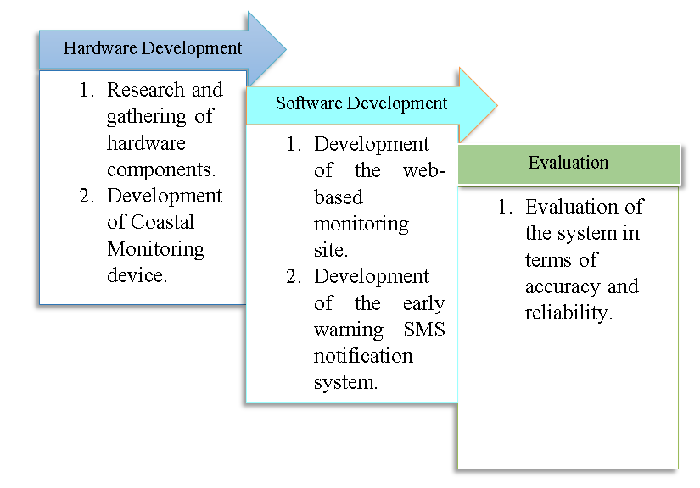

Figure 1.Conceptual Framework of the Study.

Figure 1 shows the Conceptual Framework of the Study. The first phase involves researching and gathering the hardware components needed to build the coastal monitoring device. This includes sensors and other equipment necessary to collect and transmit data about coastal conditions.

The second phase focuses on the software development aspects of the system. This includes the development of a web-based monitoring site that displays data collected by the coastal monitoring device. Moreover, developing an early warning SMS notification system for storm surge alerts was established in this phase.

The third phase involves evaluating the overall effectiveness of the system. This evaluation would likely involve assessing the accuracy and reliability of the data collected by the coastal monitoring device.

**METHODOLOGY**

This chapter presents the different stages that guided the researchers in completing the study. Additionally, it will help future researchers interested in the system understand it.

**Locale of the Study**

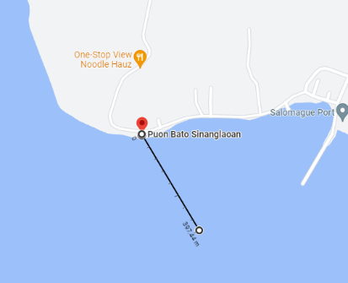

Figure 2. Site map of the coastal area at Brgy.Salomague , Cabugao, Ilocos Sur.

As seen in Figure 2, the study "Development of Coastal Monitoring System of Storm Surge and Water Level using LoRa" was carried out by researchers in the coastal area of Brgy.Salomague, Cabugao, Ilocos Sur. The white circle represents the device strategically positioned 800 meters from the shore, while the blue circle denotes the base station. The power of LoRa technology facilitated seamless connectivity and reliable data transmission between these components. The study focused on developing a coastal monitoring system that utilizes LoRa technology to measure storm surge and seafloor depth in real-time.

**Design Procedure**

The researchers used a staggered process in their framework to conduct the research. The framework helped the researchers to analyze and implement the study. A staggered process was used to show a downward progression through the stages of the research.

Figure 3. Staggered Process Model of the System.

**PHASE 1: Hardware Development.** In this phase, to complete the study, the researchers focused on modeling and planning based on the needs of the study. The researchers also developed a project plan, research design, and methodologies to guide them throughout the study. Additionally, they identified and acquired the necessary equipment and materials, such as sensors and LoRa modules. The researchers focused on gathering the necessary materials and building the coastal monitoring device for the study. They also gathered records of all possible requirements for the study, including water level, water temperature, wave height, and wave period data, to ensure accurate and reliable monitoring.

**PHASE 2: System Development.** In this phase, the researchers developed a web application and database that serve as a dashboard to monitor and store incoming data. This system would also send out alerts to the authorities and residents of the coastal area if a storm surge was imminent. This was a crucial component of the study, as it would allow people to take immediate action and ensure their safety during a storm surge. This phase aimed to create a reliable and efficient system to accurately monitor and report coastal conditions in real-time.

**PHASE 3: System Evaluation.** The researchers evaluated the system's accuracy and reliability in this phase. This determines if the system is operational. The researchers tested the system in various conditions and scenarios to ensure it performed as intended. This may involve testing individual components, such as the sensors, communication modules, and the system. The evaluation also involves comparing the data collected by the system to other sources of information to ensure that it is accurate and reliable.

**PHASE 4: Implementation**. In this phase, the researchers worked closely with the authorities and residents of the coastal area to implement the coastal monitoring system. They trained them to use the monitoring device and web application to interpret the data and respond to storm surge alerts. The researchers also conducted follow-up visits and provided technical support to ensure the system functions properly and addresses the community's needs.

**Fabrication**

This section presents the design specifications and 3D model, cost estimates, and Gantt chart for the development of the system.

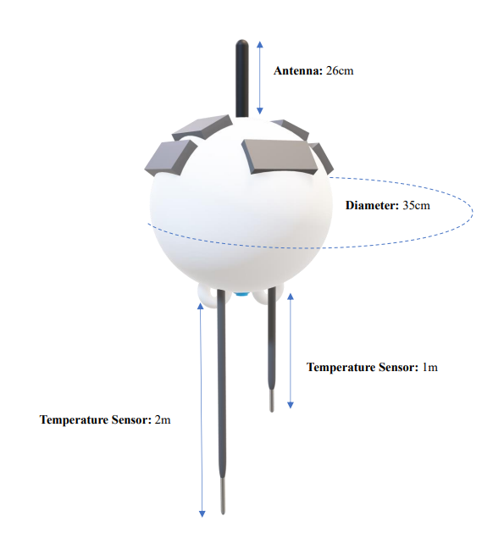

Figure 4. Buoy.

Figure 4 illustrates the design specification of the developed coastal monitoring system. The buoy is made of high-density polyethylene (HDPE) material and, measuring 35cm in diameter, underwent a fabrication process to accommodate the installation of sensors. The buoy was carefully cut in half, allowing for the placement of the temperature sensors inside. To ensure the sensors' protection from heat and water damage in case of a water breach, the inside of the buoy was coated with polyurethane foam. Additionally, a non-sag marine epoxy was employed to achieve waterproof seals around the sensor holes and reattach the buoy. For enhanced visibility and resistance to corrosion, the buoy was painted with white Pylox, a marine-grade paint.

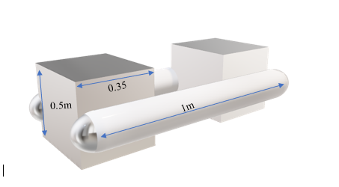

Figure 5. Stabilizer.

Figure 5 illustrates the design specification of the stabilizer. The stabilizer, made of bolo wood and plastic containers, ensures the buoy remains stable and doesn't rotate freely in the water. This configuration allows for accurate measurement of desired parameters by preventing unnecessary movement. The combination of bolo wood and plastic containers provides a balanced and reliable solution for maintaining stability in the dynamic coastal environment. This design enhancement improves the accuracy and reliability of our system, supporting effective coastal management and disaster preparedness efforts.

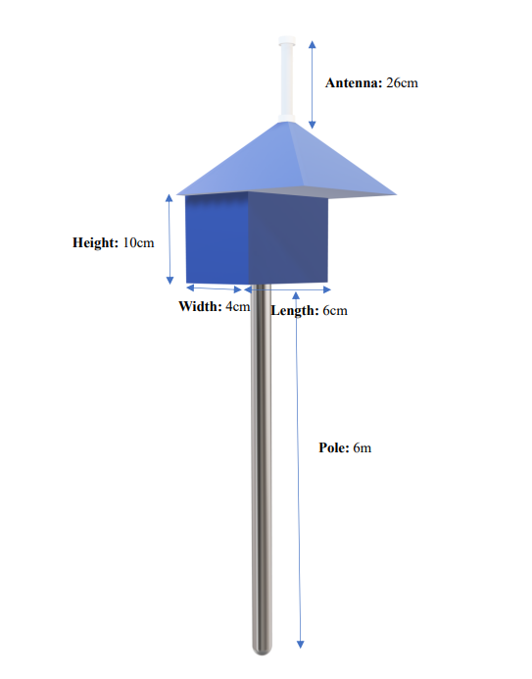

Wire

Wire

Wire

Wire

Figure 6. Base Station.

Figure 6 illustrates the design specification of the base station of the system. The base station is constructed with a 6m high stainless-steel structure with a strategic wiring configuration which serves as its foundation to ensure that stood upright and stable. Above it is a house structure where the Raspberry Pi (RPI) unit is installed. The housing is made of plywood, coated with marine epoxy for waterproofing, and painted with Pylox, a marine-grade paint, to enhance its durability and resistance to environmental elements. Additionally, an antenna with a height of 26cm is attached above the housing to facilitate communication.

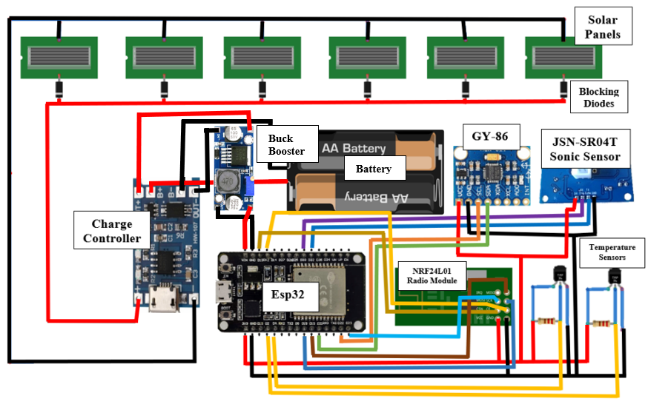

Figure 7. Circuit Diagram of the system in the buoy.

Figure 7 shows the circuit diagram of the components used in the coastal monitoring system, focusing on the buoy configuration. Comprised various components interconnected through specific pins on the ESP32 microcontroller. These components include solar panels, blocking diodes, a charge controller, a buck booster, a 3600mAh battery, a GY-86 module, an ESP32 microcontroller, a JSN-SR04T sonic sensor, an NRF24l01 radio module, and DS19B20 temperature sensors.

The solar panels capture sunlight and convert it into electrical energy. The blocking diodes prevent reverse current flow, ensuring efficient battery charging. The charge controller regulates the charging process to prevent overcharging and maximize battery life. The buck booster stabilizes the voltage supply at 5V.

The 3600mAh battery serves as a power source for continuous operation. The GY-86 module integrates sensors such as a gyroscope, accelerometer, and magnetometer. The GY-86 SCL pin is connected to GPIO22, and the GY-86 SDA pin is connected to GPIO21 on the ESP32 microcontroller.

The ESP32 microcontroller manages data transmission and communication and is the central processing unit. The JSN-SR04T sonic sensor measures sea floor depth using sound waves. The SONIC TX (ECHO) pin is connected to GPIO32, and the SONIC RX (TRIG) pin is connected to GPIO33.

The NRF24l01 radio module enables wireless communication with the base station. The RADIO CE pin is connected to GPIO12, the RADIO CSN pin to GPIO13, the RADIO MISO pin to GPIO19, the RADIO MOSI pin to GPIO23, and the RADIO SCK pin to GPIO18.

Finally, the DS19B20 temperature sensors monitor the environmental temperature. The Water Temp1 pin is connected to GPIO4, and the Water Temp2 pin is to GPIO2 on the ESP32 microcontroller.

With these components and their respective pin connections, the coastal monitoring system can effectively capture environmental data, monitor seafloor depth, measure temperature, and wirelessly transmit information for analysis and decision-making.

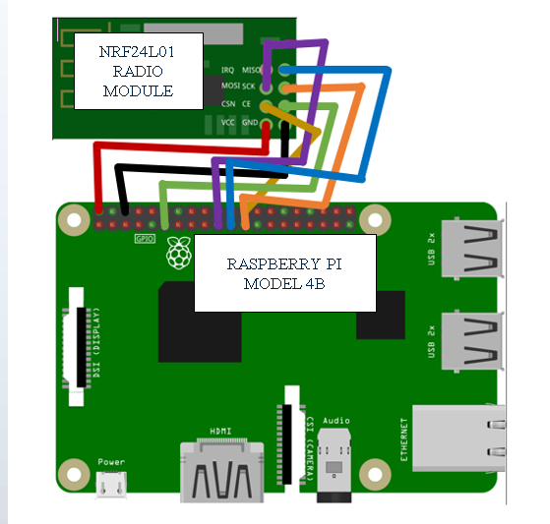

Figure 8. Circuit Diagram of the base station.

Figure 8 illustrates the circuit diagram of the coastal monitoring system, focusing on the base station configuration. The base station comprises a radio module connected to a Raspberry Pi (RPI) microcontroller. The radio module facilitates wireless communication between the base station and the remote monitoring system. It serves as the interface for data reception. The RPI microcontroller is the central processing unit, managing the communication process and processing the received data.

**Overall load of the system**

* Load= ESP(60mA)+ LORA (0.8mA)+ SONIC SENSOR(17.5Ma)+ TEMP SENSOR(2mA)+ GY-86(5mA)+BUCK BOOSTER(200mA) = 285.3Ma (1)
* BATTERY LIFE = $\frac{Bc}{\frac{IatA}{ta+ts}+\frac{Ists}{ta+ts}}=\frac{3600mAh*20\%}{\frac{285.3mA*30}{30+330}+\frac{0.330}{30+330}}=121.135Hrs=5.04 Days$ (2)

Where: Bc= Battery capacity in mAh, Ia = Device current consumption when awake in mA, Is= Device current consumption when Sleep Mode in mA, ta= time spent awake in seconds (per cycle), ts= Time spent in Sleep Mode in seconds (per cycle)

SOLAR PANEL CURRENT= 0.3W*8(panels)÷5V= 0.48A (3)

CHARGE TIME= 2.88Ah÷ 0.48A= 6 Hours (Full charge) (4)

**System Architecture**

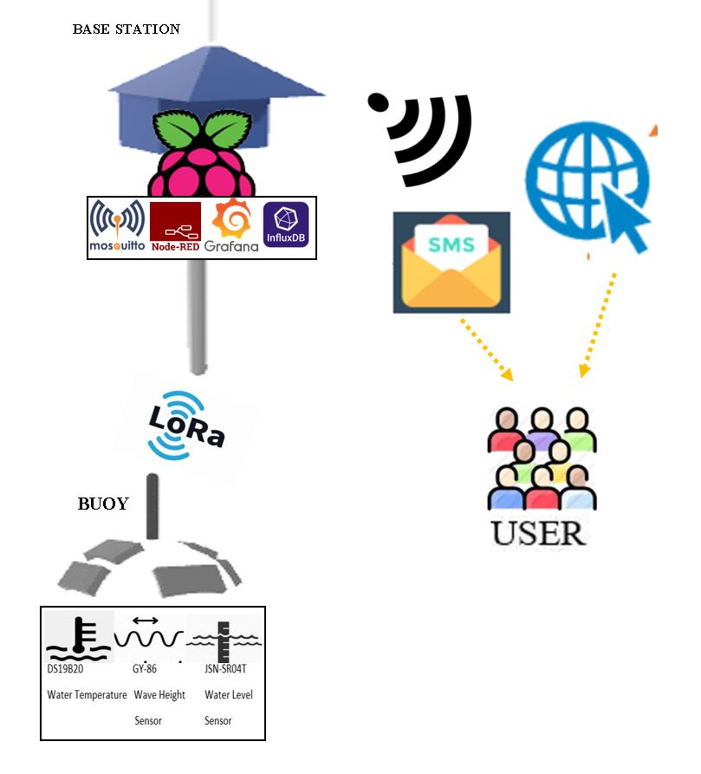

Figure 9. System Architecture.

Figure 9 illustrates the system architecture of the developed coastal monitoring system. The data gathered by the sensors, such as the water and ultrasonic sensors, is transmitted to the base station using LoRa technology. The gathered data was then received and processed by a Raspberry Pi, which served as the host. Subsequently, the data was passed to Mosquitto MQTT and bridged by Node-RED for storage in InfluxDB. The stored data was then presented graphically using Grafana for visualization and analysis.

From there, the data was made accessible through a web application, allowing users to view the information and receive early warning notifications. Additionally, SMS notifications were sent directly to compatible devices to alert the users. Users could access the web application and receive SMS notifications through their respective devices, enabling them to stay informed about the coastal conditions and potential storm surges.

**System Flowchart**

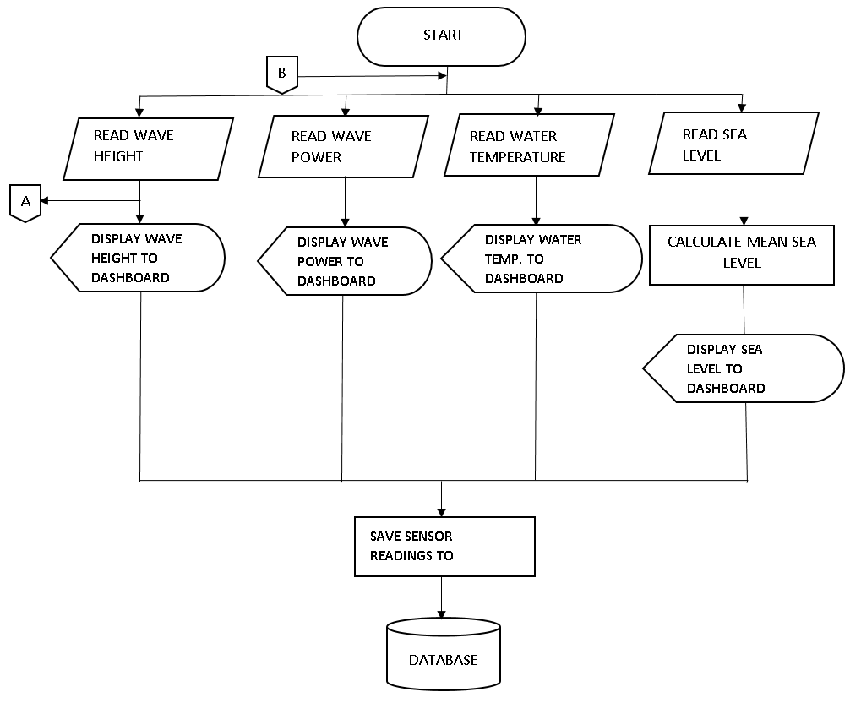

Figure 10. System Flowchart.

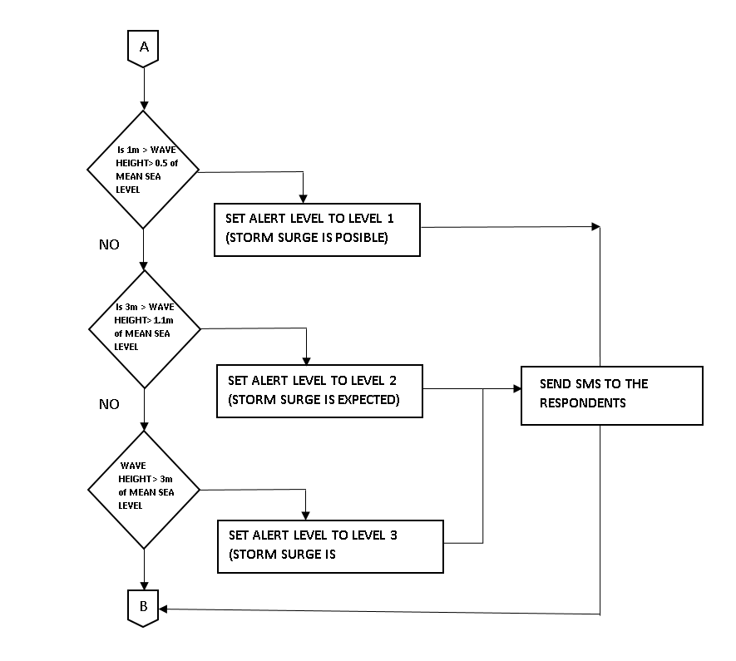Figure 10.1 System Flowchart Link A.

Figure 10 depicts the system flowchart. The data gathered by the sensors was displayed on the dashboard of the web application. The data gathered includes wave height, power, water temperature, and sea level. The sea level displayed was the hourly mean of the sea level. Then all the data was saved to the database.

**Software Flowchart**

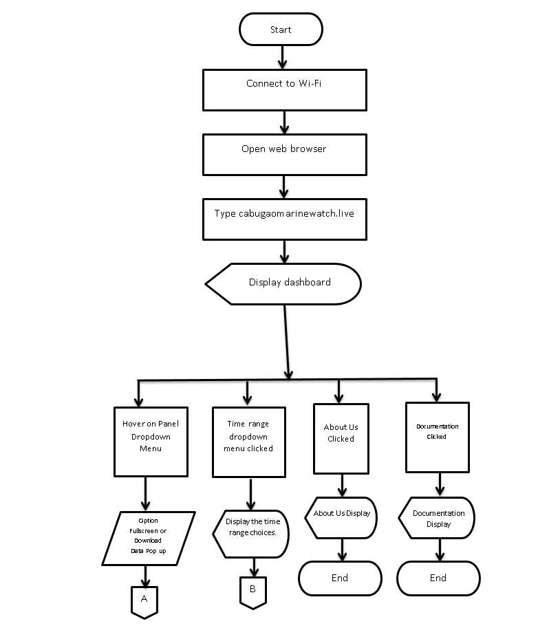

Figure 11. Software Flowchart.

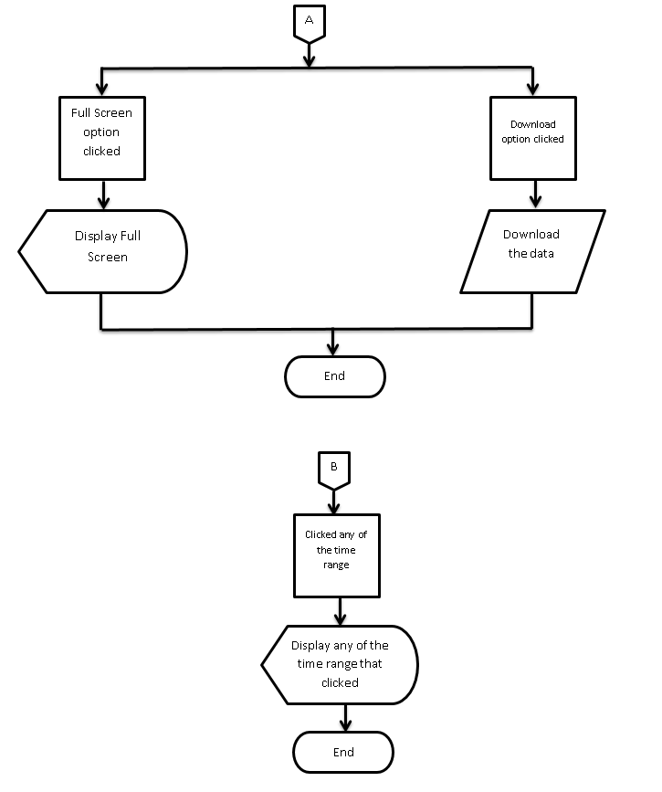

Figure 11.1 Software Flowchart Link A and B.

Figure 11 shows the user flowchart when using the web application. You connect to the internet and open your web browser. Next is to type "cabugaomarinewatch. live" into your browser. The dashboard is displayed on your screen, and you can select many options. When you click the time range and panel dropdown menu, there's an option to let you choose whether you want to download the data or a full-screen view. When the documentation is clicked, it displays several important pictures. You can also view the about us, showcasing the developers behind the system and the web application.

Table 2. System Cost.

|  |  |
| --- | --- |
| **Materials** | **Amount(PHP)** |
| Raspberry Pi 4 | ₱10,000 |
| Esp 32 | ₱200 |
| Buoy Body | ₱1,000 |
| Lora Module | ₱205 |
| LoRa Weatherproof Omnidirectional Antenna | ₱2,100 |
| DS19B20(Waterproof Thermal Temperature Sensor) | ₱379 |
| JSN-SR04T(a waterproof ultrasonic sensor) | ₱238 |
| GY-86 | ₱610 |
| Battery 3600mAh | ₱258 |
| Solar Panels | ₱568 |
| Solar Charge Controller | ₱20 |
| Step up Buck Booster | ₱89 |
| Blocking Diodes | ₱80 |
| Domain | ₱1,000 |
| Sms77 | ₱6,092 |
| Non-sag Marine Epoxy | ₱500 |
| Polyfoam | ₱1,600 |
| Pole | ₱1,800 |
| Plywood | ₱200 |
| Galon | ₱1,000 |
| Table 2. (Continued)  The metal frame of the buoy | ₱250 |
| Signal light of the buoy | ₱200 |
| Paint | ₱330 |
| Rope | ₱2,000 |
| Cement for Anchor | ₱250 |
| Nylon | ₱350 |
| **TOTAL:** | ₱32,919 |
|  |  |

Table 2.shows the system costs of building and developing the testing sites and the system. The overall cost of materials used to develop the system is Php. 32,919.00.

Table 3. Gantt Chart.

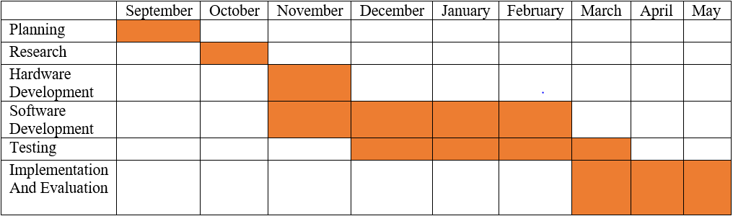

Table 3 shows the Gantt Chart for the development of the system. From September to November, the planning and research on how the system was developed, while from mid-November to February, is software and hardware development. December is also the start of testing which involves debugging and quality assurance. The implementation and evaluation involve deploying the developed software and hardware systems in their intended environment from March to May. Also, the evaluation and feedback collection.

**Testing Procedure**

A series of simulated tests assessed the developed system's accuracy and reliability. A comparison of the data obtained through simulation and manual testing was made. Additionally, the data obtained from the National Mapping and Resource Information Authority (NAMRIA) and Tide-Forecast.com for the actual deployment was compared. The system's functionality and its capacity to measure seafloor depth were shown through this simulation. The project underwent numerous tests and experiments after the system was created to ensure the system's accuracy and reliability.

**Data Gathering Procedures**

Many strategies were used to acquire all the necessary data and information for the system's growth.

They are as follows:

The researchers roam the internet to gather and collect information or data needed for creating the desired web application and warning system.

**Analysis,** the researcher analyzes books, journals, research, and thesis works related to the study that served as a basis for creating the web application and warning system.

Questionnaires were created and disseminated to obtain important information from the respondents. Prior to and following the system test, the researchers administered the questionnaire. It provided feedback from the chosen population's perspective, mainly the Brgy residents. Salomague, Cabugao Ilocos Sur, regarding their experience with our system, collected additional data needed to complete the study.

The researchers gathered data from National Mapping and Resource Information Authority (NAMRIA) and Tide-Forecast.com, specifically readings on wave height for NAMRIA and the wave period and water temperature. Also, the manual measurement for the sea floor depth.

**Research Instruments**

The major hardware and software materials required to construct the system are detailed in this category.

**Hardware Resources**

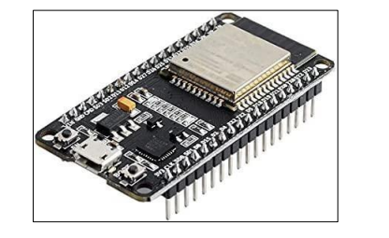

Figure 12. ESP32 Board.

Figure 12 shows the ESP 32 board. The ESP32 can collect and store data from various sensors attached to the buoy, such as temperature, pressure, humidity, and water level sensors. The collected data can be transmitted remotely for further analysis and processing. This can transmit collected data, receive commands from a remote location, or establish a two-way communication link. ESP32 can be valuable in making a buoy to collect and transmit data, communicate with a remote location, and manage its power supply.

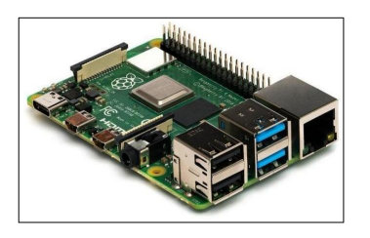

Figure 13. Raspberry Pi 4.

Figure 13 shows the Raspberry Pi 4, an affordable Linux-based computer that provides a set of General-Purpose Input/Output (GPIO) pins, enabling control of connected electronic components. The Raspberry Pi 4 was inside the base station with a radio module attached.

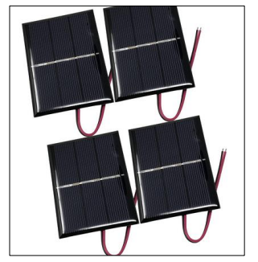

Figure 14. Solar Panel.

Figure 14 shows Solar Panel, an energy harvesting device using the sun's energy and converting it into electrical energy. This served as the main power source of the ocean-based coastal monitoring device. A solar panel with specifications of 0.3W 5V refers to a small, portable solar panel that can generate up to 0.3 watts of power and has an output voltage of 5 volts. It is compact size and lightweight design allow the solar panel to be easily carried and deployed, providing a convenient and sustainable energy source.

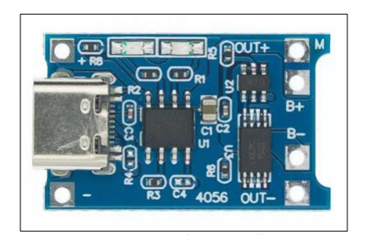

Figure 15. Charge Controller.

Figure 15 shows the charge controller, which keeps a battery from overcharging. This regulated the voltage and current from the solar panel to the coastal monitoring device's battery.

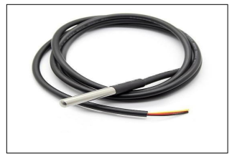

Figure 16. DS19B20, Waterproof Thermal Temperature Sensor.

Figure 16 shows the water sensor; A water temperature sensor is an electronic device designed to detect and measure the temperature of the water. It is a digital temperature sensor capable of measuring water temperature within a specific range, between 0 and 100 degrees Celsius. The water sensor plays an important role in ensuring the accuracy and reliability of water temperature measurements, which is crucial for various applications.

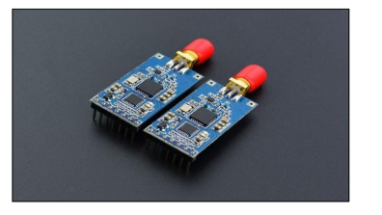

Figure 17. Long Range (LoRa) Module.

Figure 17 shows the LoRa module, LoRa (short for "long-range") is a type of radio frequency (RF) communication technology that operates in the unlicensed Industrial, Scientific, and Medical (ISM) frequency bands. LoRa was used to transmit data from the sensors to the base station, which could be located several kilometers away. Using LoRa for this purpose is advantageous due to its long-range capabilities, low power consumption, and ability to penetrate through obstacles such as walls and buildings.

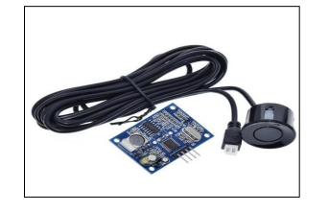

Figure 18. JSN-SR04T.

Figure 18 shows JSN-SR04T, a waterproof ultrasonic sensor that measures the distance in front of it. This served as the measuring tool of the coastal monitoring device measuring water level. Using the JSN-SR04T ultrasonic sensor in the coastal monitoring device, the system can accurately measure the water level in real-time. This information can then be used to generate alerts or reports based on predefined thresholds, which can help to prevent flooding or other potential hazards. Additionally, the sensor's waterproof design makes it well-suited for use in harsh coastal environments exposed to salt water, sand, and other elements that could damage other types of sensors.

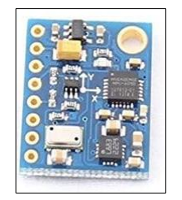

Figure 19. GY-86.

Figure 19 shows GY-86, an all-in on the accelerometer, gyroscope, barometer, and compass. This served as the measuring tool for the coastal monitoring device measuring wave power and wave height.

**Software Resources**



Figure 20. Raspbian Operating System.

Figure 20 shows Raspbian, a free OS based on Debian optimized for the Raspberry Pi. This was the operating system installed in the Raspberry Pi 4 used in the base station.



Figure 21. Arduino IDE.

Figure 21 shows the Arduino IDE, a text editor for writing code, and it is used to upload programs and communicate with the hardware connected to the Arduino.



Figure 22. VS Code.

Figure 22 shows the visual studio code. Visual Studio Code is a streamlined code editor supporting for development operations like debugging, task running, and version control. It provided tools for developing the web application for the monitoring system.



Figure 23. Sms77.

Figure 23 shows Sms77, a service provider that offers SMS (Short et al.) messaging capabilities. In the coastal monitoring system, Sms77 sends SMS notifications to compatible devices, ensuring the timely dissemination of early warning alerts and critical information to users.



Figure 24. Nginx.

Figure 24 showsNginx, a web server software widely used for its high-performance capabilities and efficient handling of concurrent connections. In the coastal monitoring system, Nginx is a reverse proxy server intermediating between client devices and the web application. It helps manage incoming requests, distribute them to the appropriate backend servers, and handle the communication between the web application and users, ensuring smooth and efficient delivery of data and responses.



Figure 25. Dataplicity.

Figure 25 shows Dataplicity, a cloud-based service that facilitates the creation of a secure tunnel, allowing researchers to web host their local host. In the coastal monitoring system, Dataplicity enables remote access to the Nginx web server running on localhost, making it accessible over the internet.

To deliver a real-time monitoring and warning notification capability of the system, the following IoT stack components are used:

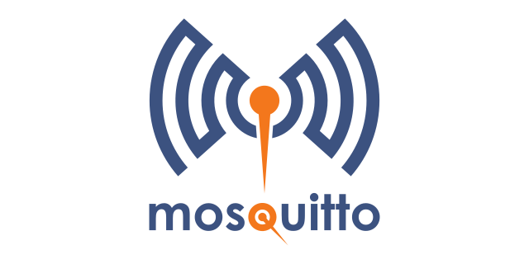

Figure 26. Mosquito MQTT.

Figure 26 shows MQTT (Message Queuing Telemetry Transport), a lightweight messaging protocol commonly used in IoT applications. Mosquito is an open-source MQTT broker that acts as a message broker, facilitating the communication and exchange of data between devices in the coastal monitoring system. It ensures reliable and efficient transmission of data across the system.



Figure 27. Node-Red.

Figure 27 showsNode-RED, a flow-based programming tool that wires together hardware devices, APIs, and online services. In the coastal monitoring system, Node-RED bridges and integrates various components, such as data flow management, message routing, and processing, enabling seamless communication between the sensors, data storage, and visualization components.



Figure 28. InfluxDB.

Figure 28 shows InfluxDB, a time-series database that handles and analyzes time-stamped data. It stores and organizes the collected sensor data in the coastal monitoring system. InfluxDB provides efficient storage and retrieval of time-series data, making it suitable for real-time tracking and analyzing trends, patterns, and anomalies.



Figure 29. Grafana.

Figure 29 showsGrafana, an open-source data visualization and analytics platform. It is used in the coastal monitoring system to present the stored sensor data from InfluxDB in a graphical format. Grafana offers a range of visualization options, including charts, graphs, and dashboards, enabling users to analyze and interpret the collected data intuitively and meaningfully.

The languages that were used are listed below:

**Python**. The interpreted, object-oriented, high-level programming language with dynamic semantics. It is the language utilized in the Raspberry Pi 4.

**Node.js**. Provides a web browser-based flow editor, which is used to create JavaScript functions on the web application of the monitoring system.

**CSS.** A style sheet language is used to control the visual presentation and layout of HTML documents, including fonts, colors, and spacing. It enhances the visual appearance of the monitoring system's web application by defining the design aspects and ensuring a cohesive and visually appealing user experience.

**Data Analysis**

This part discusses the statistical measures, tests, and other analyses used in the study. Moreover, this section presents the formulae of statistical tools, the legend of symbols in the formulae, and how data are presented and interpreted.

**Statistical Tool**

The researchers used trichotomous and dichotomous scales to conduct the survey, gathering needed data for the system. Table 3 shows the Scaling System of the survey to record the respondent's answers.

Table 4. Scaling System of the Developed System.

|  |  |
| --- | --- |
| **Scaling System** | |
| **Rating Scale** | **Interpretation** |
| YES  SOMETIMES  NO | Agree  Applied most of the time  Disagree |

The researchers used a Likert scale to test the insights of the user on the system. Table 4 shows the Scaling System used that records the respondent's insights into the system that was developed.

Table 5. Scaling System of the Developed System.

|  |  |
| --- | --- |
| **Scaling System** | |
| **Rating Scale** | **Interpretation** |
| 5  4  3 | Strongly Agree  Agree  Slightly Agree |
| 2 | Disagree |
| 1 | Strongly Disagree |
|  |  |
| 4.21-5.00 | Strongly Agree |
| 3.41-4.20 | Agree |
| 2.61-3.40 | Slightly Agree |
| 1.81-2.60 | Disagree |
| 1.00-1.80 | Strong Disagree |
|  |  |

Below are the formulas used to arrive at the computation needed for the statistical tool.

The formula below was used to determine the mean of the user evaluation.

Mean = ∑ 𝑥 𝑁 (5)

Where: ∑ x = Average Score, and N = Number of Questions

The formula below was used in the functionality testing to calculate wave power.

Wave power = wave height x wave period (6)

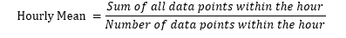The formula below was used in functionality testing to calculate the hourly mean of a set of data points.

(7)

The formula below was used in the functionality testing to compare the system readings and the manual readings to determine the percentage of error.

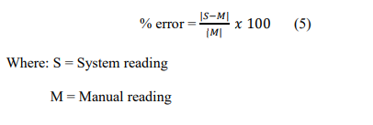

(8)

The formula below was used in the reliability testing to compare the system and data readings from NAMRIA/Tide-forecast.com to determine the error percentage.

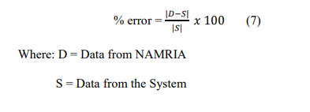

(9)

Where: D = Data from NAMRIA/Tide-forecast.com

S = Data from the system

**Definition of Terms**

To facilitate the understanding of this study, different terms are defined herein.

|  |  |
| --- | --- |
| **LoRa Technology** | It is a wireless protocol for robust, low-power communications across great distances. Long Range Radio, often known as LoRa, is primarily intended for M2M (machine-to-machine) and IoT (Internet of Things) networks. |
| **Storm Surge** | It is an abnormal rise of water level above the predicted astronomical tide caused by a storm, such as a hurricane or tropical storm. |
| **Coastal Areas** | These are geographical areas located along the coastlines of oceans, seas, lakes, or other bodies of water. |
| **National Mapping and Resource Information Authority (NAMRIA)** | It is a government agency in the Philippines responsible for providing accurate and timely information necessary for national development. It is the central mapping agency of the Philippines. It is responsible for providing base maps, charts, and other geospatial information to support various activities such as land administration, resource management, disaster risk reduction, and national security. NAMRIA also conducts surveys and mapping of Philippine territory, including the land, sea, and air domains, and serves as the national depository of geographic data. |
| **Sea floor depth rise** | This refers to the gradual ocean depth increase due to rising sea levels. |
| **Buoys** | These floating devices measure ocean parameters, such as water temperature, wave height, and wave period. |
| **National warning system** | This system is designed to provide timely warnings to the public about impending natural disasters, such as storms, floods, and earthquakes. Early warning system. This system is designed to provide advance notice of an impending disaster, such as a storm surge or tsunami, to allow people to evacuate and take necessary precautions. Raspberry Pi (Rpi). This small, affordable, and programmable computer can be used for various projects, including monitoring systems. |
| **Coastal monitoring device** | This device measures and records ocean parameters, such as water depth, temperature, and wave characteristics. |
| **Coastal erosion** | This is the gradual wearing away of land and shorelines due to the action of waves, currents, and tides. |

**RESULTS AND DISCUSSION**

This chapter discusses the process that led to the realization of the study's objectives. A thorough discussion of the developed system and its features and the results and interpretation of the data gathered are also included.

**Developed Coastal Monitoring Device**

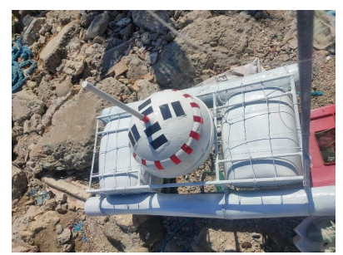 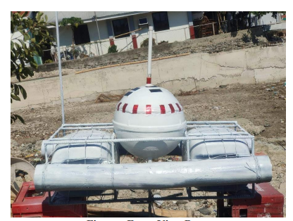

Figure 30 A. Top View Buoy. Figure 30 B. Front View Buoy.

Figure 30, A and B, shows the deployed monitoring system in the coastal area of Brgy. Salomague, Cabugao, Ilocos. The figures provide an overview of the buoy, showcasing components such as the antenna, solar panels, stabilizer, and signal light. These elements collectively contribute to the monitoring system's functionality, effectiveness, and safety

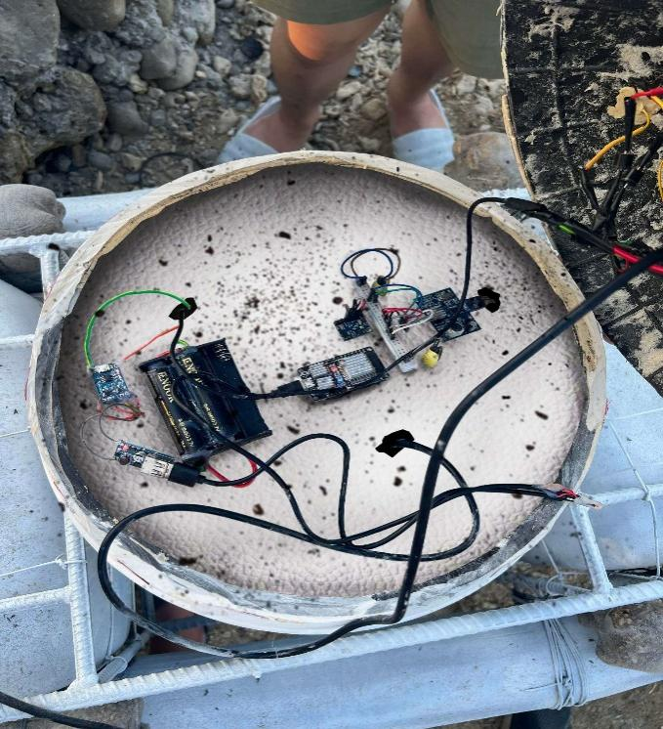

Figure 31. Inside the Buoy.

Figure 31 presents an inside view of the buoy, showcasing various components, including sensors, batteries, a charge controller, and ESP32. These components are securely placed inside the buoy and protected by visible polyurethane foam. Notably, this figure does not depict the top polyurethane foam and the outer layer of the buoy.

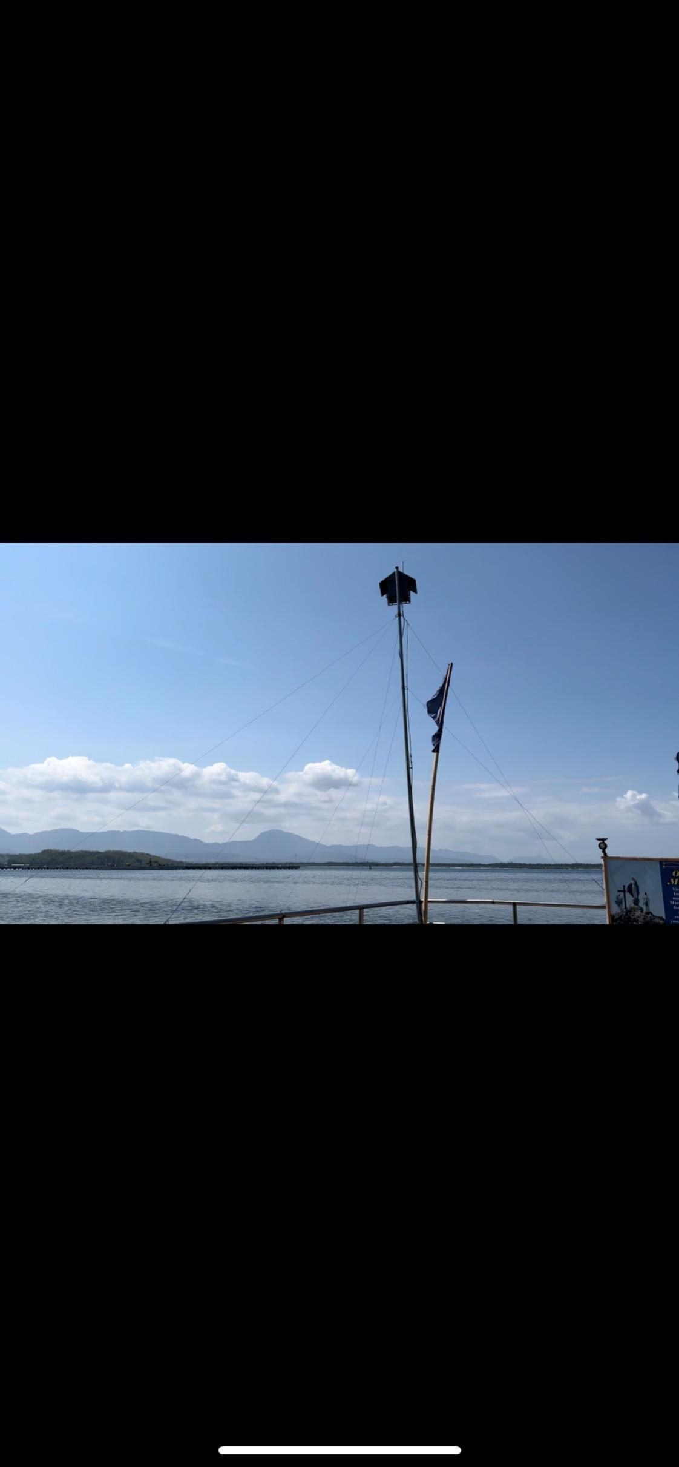

Figure 32. Base Station.

In Figure 32, the base station of the developed monitoring system is displayed. It provides an overview of the base station in the coastal area of Brgy. Salomague, Cabugao, Ilocos Sur. The image captures the base station standing upright on the ground, supported by wires. Additionally, the figure shows the antenna and the house structure mounted above the pole, which serves as the housing for the Raspberry Pi.

**Developed Web Application**

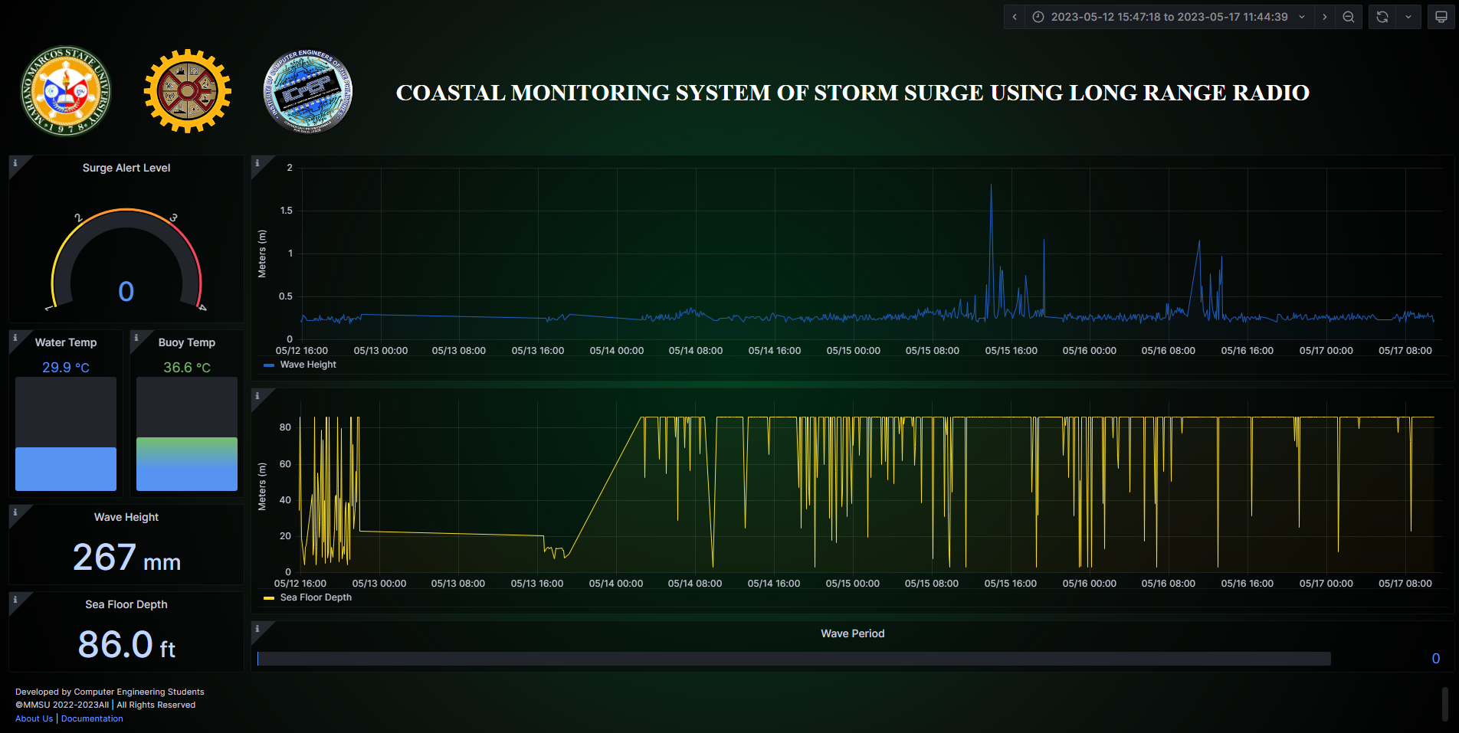

Figure 33. Website Dashboard.

This figure presents a comprehensive view of the website, showcasing the monitoring of various parameters, including wave height, power, period, seafloor depth, and the internal temperature of the device. The website provides a user-friendly real-time interface to visualize and track these important measurements.

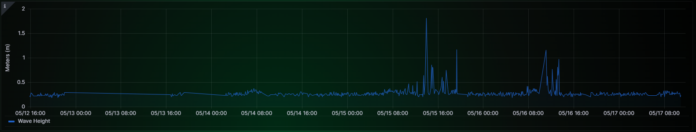

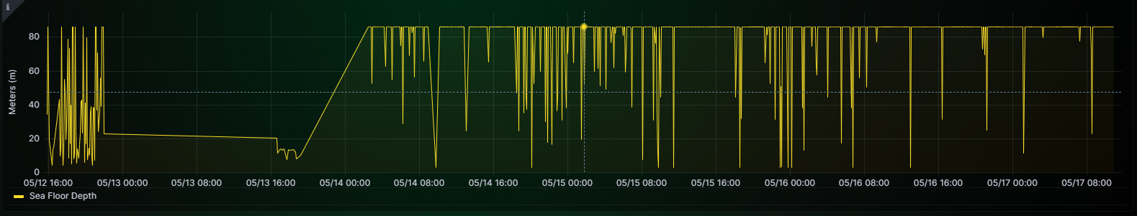

Figure 34. Wave Height and Sea depth.

Figure 34 presents a graph depicting Wave Height and Sea Depth. Notably, the sea depth is represented as negative values to create a visual contrast with the wave height and effectively illustrate the variation in depth throughout the recorded data. This approach allows for a clearer representation of the relationship between wave height and sea depth in the coastal area under study.



Figure 35. Wave Period.

In Figure 35, the wave period is displayed, representing the duration of individual waves. This graph provides valuable information on the time each wave persisted, allowing a better understanding of wave characteristics and behavior in the studied coastal area.

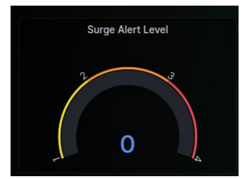

Figure 36. Surge Alert Level.

This figure presents the Surge Alert Level as an indicator of an incoming storm surge. As the alert level increases, a bar corresponding to the level is displayed, indicating the severity or magnitude of the potential storm surge. Level 1 is for a yellow warning. Level 2 is for the orange warning, and Level 3 is for the red warning. This feature aids in effectively communicating and raising awareness about the potential risks associated with varying surge levels.

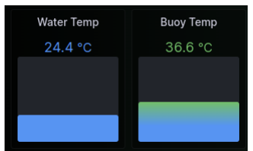

Figure 37. Water Temperature and Buoy Temperature.

Figure 37 illustrates the water temperature and buoy temperature. The water temperature represents the temperature of the sea, providing insights into the thermal conditions of the monitoring area. Meanwhile, the buoy temperature reflects the internal temperature of the monitoring device.

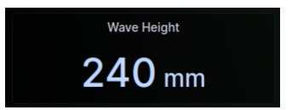

Figure 38. Wave Height.

Figure 38 presents the wave height, displaying the hourly mean of the recorded wave heights. This graph provides valuable information on the average height of waves over specific time intervals, contributing to a better understanding of the wave dynamics in the studied coastal area.

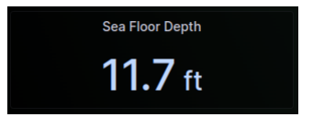

Figure 39. Sea Floor Depth.

Figure 39 showcases the sea floor depth, revealing the hourly mean of the recorded depths. This graph offers insights into the depth of the sea floor during different periods, providing valuable information for studying the underwater topography and its variations in the coastal area under monitored.

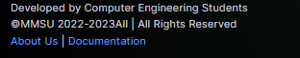

Figure 40. About Us and Documentation.

Figure 40 combines the "About Us" and "Documentation" sections, providing comprehensive information about the monitoring system's developers, contributors, and functionality. It highlights the individuals' or research team's expertise and roles, establishing credibility and acknowledging their efforts. The documentation aspect offers detailed explanations and instructions for each panel, enabling users to utilize the dashboard's features effectively and ensure efficient monitoring and analysis of relevant data.

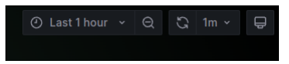

Figure 41. Set Time and Refresh Panel.

In Figure 41, the Set Time and Refresh Panel are displayed. The Set Time feature allows users to choose the specific date and time range of the data they want to view. This provides flexibility in analyzing data for specific periods of interest. The Refresh Panel allows users to customize the auto-refresh functionality of the website by selecting the desired interval in minutes or hours. This ensures that the displayed data stays up to date without requiring manual page refreshes, providing a seamless and convenient user experience.

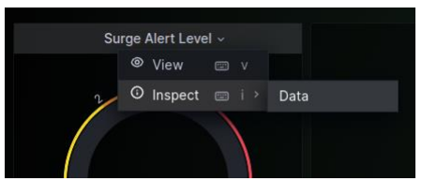

Figure 42. Panel Hover Button.

In Figure 42, the hover buttons of each panel are depicted. The View button enables users to expand a specific panel to full-screen mode, allowing for a detailed and immersive view of the data within that panel. The Inspect Data button serves as a navigation button, allowing users to access and download the underlying data associated with the respective panel. This functionality enables further analysis and exploration of the data outside the monitoring system.

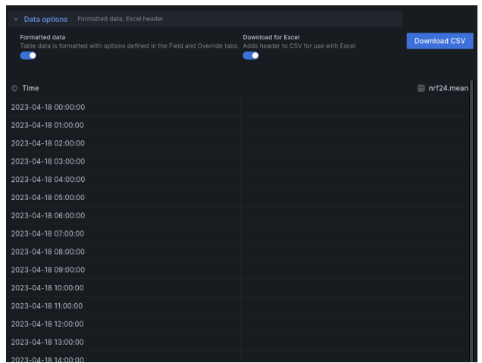

Figure 43. Data to be downloaded.

In Figure 43, the data to be downloaded is displayed. It includes a download button, allowing users to initiate the data download. The range date of the data is also indicated, providing information on the specific period covered by the dataset. Additionally, the figure presents the data organized by each date, allowing users to access and retrieve data for individual dates as needed. This facilitates further analysis and processing of the collected data.

**Evaluation of the Functionality of the System**

**Functionality Testing**

The researchers conducted an extensive series of tests to assess the functionality and performance of the Storm Surge and Water Level Monitoring System. The tests encompassed 96 trials, with 24 hourly tests conducted per day over four days, examining various wave heights. Additionally, 12 tests were conducted daily, covering three different times of the day for four days, focusing on water temperature and wave period variations. Moreover, 40 tests were carried out to analyze the accuracy of seafloor depth measurements. To evaluate the system's reliability, 24 tests were performed across six wave heights based on warning alert levels. The obtained readings were then compared with data from NAMRIA, Tide-Forecast.com, and manual readings to calculate the Percentage Error, providing insights into the system's accuracy and reliability.

Table 6. Sea Floor Depth Functionality Testing.

|  |  |  |  |  |  |  |  |
| --- | --- | --- | --- | --- | --- | --- | --- |
| **SEAFLOOR DEPTH IN m.** | | | | | | | |
| **No of Test** | **MANUAL** | **SYSTEM** | **%**  **ERROR** | **MANUAL** | **SYSTEM** | **%**  **ERROR** |  |
| 1 | 4.7 | 4.7 | 0% | 4.5 | 4.5 | 0% |  |
| 2 | 4.7 | 4.7 | 0% | 4.5 | 4.5 | 0% |  |
| 3 | 4.7 | 4.7 | 0% | 4.5 | 4.5 | 0% |  |
| 4 | 4.7 | 4.7 | 0% | 4.5 | 4.5 | 0% |  |
| 5 | 4.7 | 4.7 | 0% | 4.5 | 4.5 | 0% |  |
| 6 | 4.7 | 4.7 | 0% | 4.5 | 4.5 | 0% |  |
| 7 | 4.7 | 4.7 | 0% | 4.5 | 4.5 | 0% |  |
| 8 | 4.7 | 4.7 | 0% | 4.5 | 4.5 | 0% |  |
| 9 | 4.7 | 4.7 | 0% | 4.5 | 4.5 | 0% |  |
| 10 | 4.7 | 4.7 | 0% | 4.5 | 4.5 | 0% |  |
|  | | | | | | |  |
|  |  |  |  |  |  |  |  |
|  |  |  |  |  |  |  |  |
|  |  |  |  |  |  |  |  |
|  |  |  |  |  |  |  |  |
| Table 6. (Continued) | | | | | | |  |
| **SEAFLOOR DEPTH IN m.** | | | | | | |
| **No of Test** | **MANUAL** | **SYSTEM** | **%**  **ERROR** | **MANUAL** | **SYSTEM** | **%**  **ERROR** |  |
| 1 | 4 | 4 | 0% | 3.7 | 3.7 | 0% |  |
| 2 | 4 | 4 | 0% | 3.7 | 3.7 | 0% |  |
| 3 | 4 | 4 | 0% | 3.7 | 3.7 | 0% |  |
| 4 | 4 | 4 | 0% | 3.7 | 3.7 | 0% |  |
| 5 | 4 | 4 | 0% | 3.7 | 3.7 | 0% |  |
| 6 | 4 | 4 | 0% | 3.7 | 3.7 | 0% |  |
| 7 | 4 | 4 | 0% | 3.7 | 3.7 | 0% |  |
| 8 | 4 | 4 | 0% | 3.7 | 3.7 | 0% |  |
| 9 | 4 | 4 | 0% | 3.7 | 3.7 | 0% |  |
| 10 | 4 | 4 | 0% | 3.7 | 3.7 | 0% |  |
|  | | | | | | | |
|  | | | | | | | |

Table 6 showcases a comparison between the system readings obtained with the JSN-SR04T Waterproof Ultrasonic Sensor integrated into the monitoring system and the manual readings acquired using a measuring device composed of measuring tape and a barrel container, which has been utilized in the simulated functionality testing phase. This table evaluates the agreement and consistency between the automated system readings and the manual measurements, providing insights into the system's accuracy and reliability.

|  |  |  |  |  |  |  |
| --- | --- | --- | --- | --- | --- | --- |
| Table 7. Sea Temperature Functionality Testing. | | | | | |  |
| **SEA TEMPERATURE IN CELCIUS** | | | | | |  |
| **5-12-23** | | | | **5-13-23** | |  |
| **TIME** | **Tide-Forecast** | **SYSTEM** | **% ERROR** | **Tide-Forecast** | **SYSTEM** | **% ERROR** |
| 0:00 - 10:00 AM | **High** 31°C  **Low** 26°C | **High** 30°C  **Low** 25°C | 3%  3% | **High** 32°C  **Low** 29°C | **High**  °C  **Low**  °C | 0%  0% |
| 11:00 – 5:00 PM | **High** 30°C  **Low** 30°C | **High** 30°C  **Low** 29°C | 0%  3% | **High** 32°C  **Low** 31°C | **High** 30°C  **Low** 29°C | 10%  10% |
| 6:00 – 23:00 | **High** 26°C  **Low** 28°C | **High** 29°C  **Low** 29°C | 10%  3% | **High** 29°C  **Low** 27°C | **High**  °C  **Low**  °C | 0%  0% |

|  |  |  |  |  |  |  |  |  |
| --- | --- | --- | --- | --- | --- | --- | --- | --- |
|  | | | | | | | | |
|  | | | | | | | | |
|  | | | | | | | | |
|  | | | | | | | | |
|  | | | | | | | | |
|  | | | | | | | | |
|  | | | | | | | | |
| Table 7. (Continued) | | | | | | | | |
| **SEA TEMPERATURE IN CELCIUS** | | | | | | | | |
| **5-14-23** | | | **5-15-23** | | | |
| **TIME** | **Tide-Forecast** | **SYSTEM** | | **% ERROR** | **Tide-Forecast** | **SYSTEM** | | **% ERROR** |
| 0:00 - 10:00 AM | **High** 29°C  **Low** 29°C | **High** 29°C  **Low** 29°C | | 0%  0% | **High** 29°C  **Low** 26°C | **High** 29°C  **Low** 29°C | | 0%  10% |
| 11:00 – 5:00 PM | **High** 31°C  **Low** 31°C | **High** 30°C  **Low** 30°C | | 3%  3% | **High** 32°C  **Low** 30°C | **High** 32°C  **Low** 31°C | | 0%  3% |
| 6:00 – 23:00 | **High** 29°C  **Low** 26°C | **High** 29°C  **Low** 29°C | | 0%  10% | **High** 33°C  **Low** 30°C | **High** 33°C  **Low** 30°C | | 0%  0% |
|  |  |  | |  |  |  | |  |

Table 7 compares the system readings obtained using the DS19B20 Waterproof Thermal Temperature Sensor integrated into the developed monitoring system and the data provided by Tide-Forecast.com. The data presented were the highest and lowest water temperature within the given time range. This table allows for assessing the consistency and accuracy of the system's readings compared to the established data source. Based on the computed percentage error ranging from 0% to 3% of the gathered data from Tide-Forecast.com, it shows that it is below the percentage error, and out of the 12 trials, there's also a computed 5 out of the set of the percentage error.

Table 8. Wave Period Functionality testing. WAVE PERIOD IN SECONDS.

|  |  |  |  |  |  |  |  |  |  |  |  |  |
| --- | --- | --- | --- | --- | --- | --- | --- | --- | --- | --- | --- | --- |
| **WAVE PERIOD IN SECONDS** | | | | | | | | | | | | |
| **5-12-23** | | | | | | | **5-13-23** | | | | | |
| **TIME** | **Tide-Forecast** | | **SYSTEM** | | **% ERROR** | | **Tide-Forecast** | | **SYSTEM** | | **% ERROR** | |
| 0:00 - 10:00 AM | 0.2 | | 0.2 | | 0% | | 0.4 | | 0.4 | | 0% | |
| 11:00 – 5:00 PM | 0.2 | | 0.2 | | 0% | | 0.4 | | 0.4 | | 0% | |
| 6:00 – 23:00 | 0.2 | | 0.2 | | 0% | | 0.4 | | 0.4 | | 0% | |
|  |  | |  | |  | |  | |  | |  | |
| Table 8. (Continued) | | | | | | | | | | | | | |
| **WAVE PERIOD IN SECONDS** | | | | | | | | | | | | | |
|  | | **5-14-23** | | | | | | **5-15-23** | | | | | |
| **TIME** | | **Tide-Forecast** | | **SYSTEM** | | **% ERROR** | | **Tide-Forecast** | | **SYSTEM** | | **% ERROR** | |
| 0:00 - 10:00 AM | | 0.2 | | 0.2 | | 0% | | 0.2 | | 0.2 | | 0% | |
| 11:00 – 5:00 PM | | 0.2 | | 0.2 | | 0% | | 0.2 | | 0.2 | | 0% | |
| 6:00 – 23:00 | | 0.2 | | 0.2 | | 0% | | 0.2 | | 0.2 | | 0% | |

Table 8 compares the system readings obtained using the GY-86 Sensor integrated into the developed monitoring system and the data provided by Tide-Forecast.com. The data presented were the mean of the collected data between the given time range. This table allows for assessing the consistency and accuracy of the system's readings compared to the established data source. Based on the computed percentage error of the gathered data from NAMRIA and Tide-Forecast are the same.

Table 9. Wave Height Functionality testing.

|  |  |  |  |  |  |  |
| --- | --- | --- | --- | --- | --- | --- |
| **WAVE HEIGHT IN METERS** | | | | | | |
| **5-12-23** | | | | **5-13-23** | | |
| **TIME** | **NAMRIA** | **SYSTEM** | **% ERROR** | **NAMRIA** | **SYSTEM** | **% ERROR** |
| 0:00:00 | 0.227 | 0.227 | 0% | 0.2291 | - | - |
| 1:00:00 | 0.249 | 0.249 | 0% | 0.231 | - | - |
| 2:00:00 | 0.233 | 0.233 | 0% | 0.236 | - | - |
| 3:00:00 | 0.240 | 0.240 | 0% | 0.233 | - | - |
| 4:00:00 | 0.251 | 0.252 | 0.3% | 0.243 | - | - |
| 5:00:00 | 0.326 | 0.324 | 0.6% | 0.235 | - | - |
| 6:00:00 | 0.240 | 0.239 | 0.4% | 0.236 | - | - |
| 7:00:00 | 0.248 | 0.248 | 0% | 0.239 | - | - |
| 8:00:00 | 0.289 | 0.289 | 0% | 0.233 | - | - |
| 9:00:00 | 0.334 | 0.335 | 0.2% | 0.249 | - | - |
| 10:00:00 | 0.267 | 0.266 | 0.3% | 0.231 | - | - |
| 11:00:00 | 0.261 | 0.260 | 0.3% | 0.247 | - | - |
| 12:00:00 | 0.263 | 0.262 | 0.3% | 0.242 | - | - |
| 13:00:00 | 0.261 | 0.263 | 0.7% | 0.244 | - | - |
| 14:00:00 | 0.245 | 0.246 | 0.2% | 0.231 | - | - |
| Table 9. (Continued) | | | | | | |
| 15:00:00 | 0.242 | 0.242 | 0% | 0.237 | - | - |
| 16:00:00 | 0.243 | 0.243 | 0% | 0.234 | 0.234 | 0% |
| 17:00:00 | 0.242 | 0.242 | 0% | 0.241 | 0.240 | 0.3% |
| 18:00:00 | 0.238 | 0.238 | 0% | 0.249 | 0.249 | 0% |
| 19:00:00 | 0.231 | 0.231 | 0% | 0.291 | 0.292 | 0.3% |
| 20:00:00 | 0.249 | 0.249 | 0% | 0.213 | - | - |
| 21:00:00 | 0.246 | 0.246 | 0% | 0.209 | - | - |
| 22:00:00 | 0.293 | 0.293 | 0% | 0.208 | - | - |
| 23:00:00 | 0.227 | - | - | 0.211 | - | - |
| **"–"** means No data | | | | | | |
| Table 9. (Continued) | | | | | | |
| **WAVE HEIGHT IN METERS** | | | | | | |
|  | **5-14-23** | | | **5-15-23** | | |
| **TIME** | **NAMRIA** | **SYSTEM** | **% ERROR** | **NAMRIA** | **SYSTEM** | **% ERROR** |
|  | | | | | | |
| 0:00:00 | 0.211 | - | - | 0.255 | 0.257 | 0.7% |
| 1:00:00 | 0.213 | - | - | 0.250 | 0.250 | 0% |
| 2:00:00 | 0.246 | 0.246 | 0% | 0.244 | 0.244 | 0% |
| 3:00:00 | 0.253 | 0.251 | 0.7% | 0.265 | 0.267 | 0.7% |
| 4:00:00 | 0.262 | 0.261 | 0.3% | 0.263 | 0.263 | 0% |
| Table 9. (Continued) | | | | | | |
| 5:00:00 | 0.252 | 0.253 | 0.3% | 0.263 | 0.265 | 0.7% |
| 6:00:00 | 0.295 | 0.297 | 0.6% | 0.383 | 0.283 | 0% |
| 7:00:00 | 0.326 | 0.328 | 0.6% | 0.320 | 0.320 | 0% |
| 8:00:00 | 0.29 | 0.29 | 0% | 0.313 | 0.313 | 0% |
| 9:00:00 | 0.224 | 0.226 | 0.8% | 0.286 | 0.287 | 0.3% |
| 10:00:00 | 0.241 | 0.240 | 0.4% | 0.328 | 0.328 | 0% |
| 11:00:00 | 0.254 | 0.256 | 0.7% | 0.301 | 0.301 | 0% |
| 12:00:00 | 0.260 | 0.258 | 0.7% | 0.285 | 0.285 | 0% |
| 13:00:00 | 0.260 | 0.260 | 0% | 0.520 | 0.520 | 0% |
| 14:00:00 | 0.254 | 0.255 | 0.3% | 0.381 | 0.380 | 0.2% |
| 15:00:00 | 0.255 | 0.265 | 0% | 0.558 | 0.558 | 0% |
| 16:00:00 | 0.269 | 0.269 | 0% | 0.378 | 0.379 | 0.2% |
| 17:00:00 | 0.234 | 0.236 | 0.8% | 0.389 | 0.388 | 0.2% |
| 18:00:00 | 0.246 | 0.247 | 0.4% | 0.295 | 0.295 | 0% |
| 19:00:00 | 0.241 | 0.241 | 0% | 0.453 | 0.453 | 0% |
| 20:00:00 | 0.254 | 0.255 | 0.3% | 0.222 | - | - |
| 21:00:00 | 0.263 | 0.264 | 0.3% | 0.261 | 0.261 | 0% |
| Table 9. (Continued) | | | | | | |
| 22:00:00 | 0.248 | 0.248 | 0% | 0.256 | 0.256 | 0% |
| 23:00:00 | 0.263 | 0.263 | 0% | 0.252 | 0.252 | 0% |
| **"–"** means No data | | | | | | |
|  |  |  |  |  |  |  |  |

Table 9 compares the system readings obtained using the GY-86 sensor integrated into the developed monitoring system and the data provided by NAMRIA. The system readings were acquired during the deployment period of the monitoring system, while the NAMRIA data were gathered using a satellite-based device. This table allows for assessing the consistency and accuracy of the system's readings compared to the established data source. The presented data show the hourly mean of the data gathered every 5 minutes. Based on the computed percentage error ranging from 0% to 0.8% of the gathered data from NAMRIA and the system, it shows that it is below the percentage error. Meanwhile, unavailable data on the developed system was due to the interruption of frequency of the LoRa and unexpected power interruption.

Table 10. Alert Level Functionality testing.

|  |  |  |  |  |  |  |  |  |  |  |  |  |  |  |  |  |
| --- | --- | --- | --- | --- | --- | --- | --- | --- | --- | --- | --- | --- | --- | --- | --- | --- |
| **WAVE HEIGHT IN DIFFERENT LEVELS** | | | | | | | | | | | | | | | | |
| **LEVEL 0** | | | | | | | | | **LEVEL 1** | | | | | | |
| **No. of Tests** | | **Manual** | | **SYSTEM** | | | **SMS** | | **Manual** | | **SYSTEM** | | | **SMS** | |
| 1 | | 0 | | 0 | | | None | | 0.5 | | 0.5 | | | Received | |
| 2 | | 0 | | 0 | | | None | | 0.6 | | 0.6 | | | Received | |
| 3 | | 0 | | 0 | | | None | | 0.7 | | 0.7 | | | Received | |
| 4 | | 0 | | 0 | | | None | | 0.8 | | 0.8 | | | Received | |
| 5 | | 0 | | 0 | | | None | | 0.9 | | 0.9 | | | Received | |
| 6 | | 0 | | 0 | | | None | | 1.0 | | 1.0 | | | Received | |
|  |  | | | | | | | | | | |  | | | | | |
| Table 10. (Continued) | | | | | | | | | | | | | | | | | |
| **WAVE HEIGHT IN DIFFERENT LEVELS** | | | | | | | | | | | | | | | | | |
| **LEVEL 2** | | | | | |  | | | | | | | **LEVEL 3** | | | | | |
| **No. of Tests** | **Manual** | | **SYSTEM** | | **SMS** | | | **Manual** | | **SYSTEM** | |  | | | **SMS** | | | |
| 1 | 1.1 | | 1.1 | | Received | | | 3.1 | | 3.1 | |  | | | Received | | | |
| 2 | 1.5 | | 1.5 | | Received | | | 3.1 | | 3.1 | |  | | | Received | | | |
| 3 | 2.0 | | 2.0 | | Received | | | 3.1 | | 3.1 | |  | | | Received | | | |
| 4 | 2.1 | | 2.1 | | Received | | | 3.2 | | 3.2 | |  | | | Received | | | |
| 5 | 2.5 | | 2.5 | | Received | | | 3.2 | | 3.2 | |  | | | Received | | | |
| 6 | 3.0 | | 3.0 | | Received | | | 3.2 | | 3.2 | |  | | | Received | | | |
|  |  | |  | |  | | |  | |  | |  | | |  | | | |

Table 10 presents the effectiveness of SMS notifications triggered by the alert levels determined by wave height parameters. The table demonstrates that SMS notifications were successfully received by both Barangay Officials and residents when the wave height surpassed the threshold for alert levels 1, 2, and 3. Upon meeting the criteria for each alert level, a single text message was sent to the respective recipients, ensuring timely communication and necessary actions in response to the identified wave height conditions.

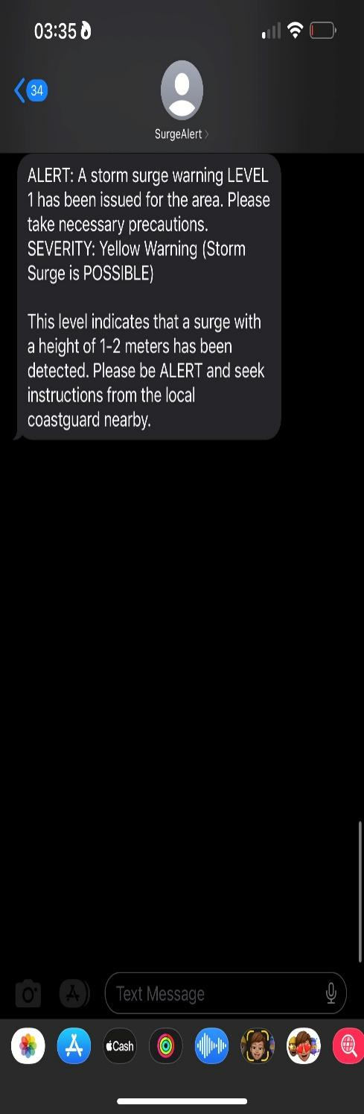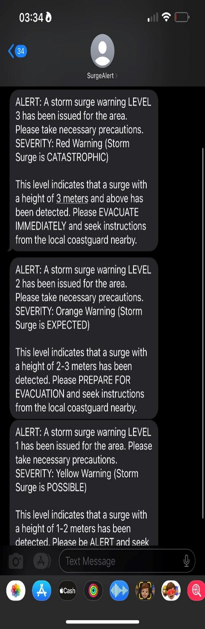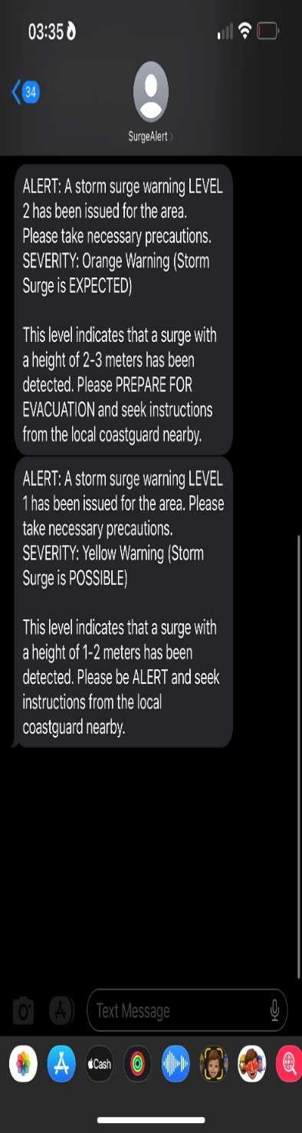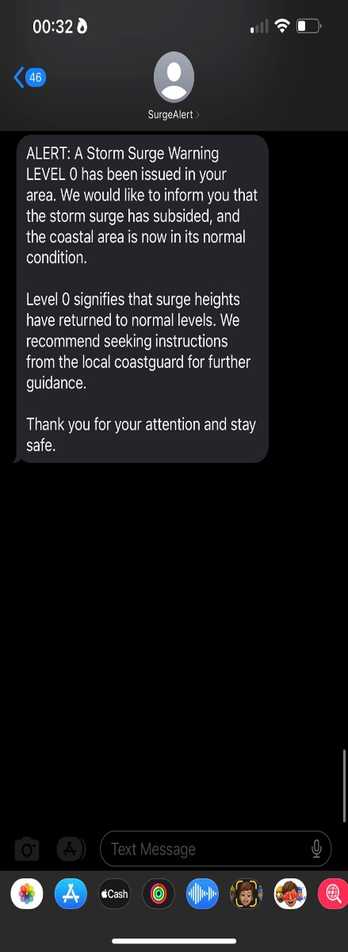

Figure 44. Sample of SMS Notification.

Figure 44 displays a sample of the received SMS containing essential information related to the corresponding alert level. The SMS includes details such as the recorded wave height, a concise description of the alert level, the color associated with the specific alert level, and instructions on the appropriate actions to respond to the alert level. This sample SMS is a clear and informative communication tool, providing recipients with crucial information to ensure their safety and appropriate response during different alert levels.

**Functionality from User Evaluation**

The researchers collected data through questionnaires consisting of ten (10) questions related to the dashboard, data table, notification system, and overall satisfaction with the system. The respondents, who were Brgy. Officials and residents of Brgy. Salomague, Cabugao, Ilocos Sur totaled twenty (20). The functionality parameter received a mean score of 4.92, indicating a high level of agreement among the respondents, placing it in the "Strongly Agree" category on the five-point Likert Scale. This demonstrates the participants' positive perception and acceptance of the system's functionality.

**Advantages and Disadvantages of the Developed System**

Real-time Monitoring, the developed coastal monitoring system provides real-time data on seafloor depth, water temperature, wave height, and wave period. This gives authorities and residents up-to-date information about the coastal conditions, allowing them to make timely decisions and take appropriate actions to mitigate potential risks.

Dependency on Power Supply, the system’s base station relies on a stable power supply to operate effectively. In cases of power outages or disruptions, there may be a temporary loss of data transmission and monitoring capabilities.

**SUMMARY, CONCLUSION, AND RECOMMENDATION**

**Summary of the Findings**

Based on the study's objectives, the findings and results have demonstrated the achievement of the set objectives. The researchers successfully developed a Coastal Monitoring System of Storm Surge and Water Level using Long Range Radio, which includes a web application with SMS notification capabilities for monitoring seafloor depth, water temperature, wave height, and wave period. The system performed accurately and reliably during simulated tests, and the comparison with data obtained from NAMRIA and Tide-Forecast.com confirmed its adherence to established standards. These findings indicate that the system effectively meets the objectives of providing early warning notifications and coastal monitoring of storm surges in the study area.

**Conclusion**

This study sought to develop a coastal monitoring system of storm surges and water levels using Long Range Radio that monitored the sea floor depth, water temperature, water level, and wave period in Brgy. Salomogue, Cabugao, Ilocos Sur.

The system kept the people safe by monitoring the coastal area via a web application and a Short Message Service (SMS) notification system for efficient dissemination of critical information like alert levels and warnings to coastal residents and authorities. The researchers designed and tested all of the system's objectives effectively.

The system also produced excellent results during the functional test, suggesting that it was successful and beneficial. Because of its accuracy, efficiency, and reliability, the researchers concluded that the system would greatly help the residents of Brgy. Salomogue, Cabugao, Ilocos Sur.

**Recommendations**

Recommendations in light of the results obtained from the findings and conclusion, the researchers have the following suggestions:

1. It is recommended to ensure a stable and fast Wi-Fi signal to maintain continuous and real-time data transmission over the web application.

2. It is recommended that the distance of the buoy must be more than 800 meters to a port to prevent interruptions in data transmission and ensure reliable communication between the buoy and the base station.

3. Utilizing a solar-powered supply as a backup in case of power interruptions is recommended. This will help maintain the system's functionality even during power outages and ensure the web application's uninterrupted data transmission and viewability.

**Literature Cited**

**Jones, A., Smith, B., & Johnson, C. (2022).** Precise measurement of storm surge using radar technology. Oceanography Research, 12(3), 45–56.

**Smith, B., Johnson, C., & Jones, A. (2023).** Measuring water temperature at multiple depths using a submersible thermometer. Journal of Oceanography, 23(1), 78–89.

**LoRa Alliance. (n.d.).** LoRa and LoRaWAN. Retrieved from https://lora-developers.semtech.com/documentation/tech-papers-and-guides/lora-and-lorawan

**National Mapping and Resource Information Authority. (n.d.).** NAMRIA is ISO Re-Certified. Retrieved from https://www.namria.gov.ph/list.php?id=2945&alias=namria-is-iso-re-certified&Archive=1

**Asnaashari, A., Sadeghi-Niaraki, A., & Sadeghi, M. (2019).** Investigation of ultrasonic sensor type JSN-SRT04 performance as flood elevation detection. ResearchGate. Retrieved from https://www.researchgate.net/publication/335366797_Investigation_of_ultrasonic_sensor_type_JSN-SRT04_performance_as_flood_elevation_detection

**Asnaashari, A., Sadeghi-Niaraki, A., & Sadeghi, M. (2019).** Investigation of ultrasonic sensor type JSN-SRT04 performance as flood elevation detection. ResearchGate. Retrieved from https://www.researchgate.net/publication/335366797_Investigation_of_ultrasonic_sensor_type_JSN-SRT04_performance_as_flood_elevation_detection

**Wang, T., Li, Z., Song, X., Zhang, H., & Zhu, Q. (2020).** Application of IoT technology in water level monitoring systems based on LoRa and NB-IoT. IEEE Access, p. 8, 13518–13528. doi:10.1109/ACCESS.2020.2968924

**Talukder, M. H., Islam, M. S., Rahman, M. M., & Hannan, M. A. (2018).** Development of a Low-Cost Water Level Monitoring System Using Internet of Things (IoT) Technology. Sensors, 18(6), 1831. doi:10.3390/s18061831

**Ahmad, M. A., Nurizzati, M. D., & Shah, Z. M. (2021).** Flood monitoring system using ultrasonic sensor JSN-SR04T and SIM 900A. ResearchGate. Retrieved from https://www.researchgate.net/publication/351468032_Flood_monitoring_system_using_ultrasonic_sensor_SN-SR04T_and_SIM_900

**Haq, E. S., Suwardiyanto, D., Ayatullah, M. D., Rini, E. M., Sutiksno, H., & Setyati, E. (2019).** The Coastal Early Warning System Based on Buoy Sensor Measurement. Proceedings - 2019 2nd International Conference of Computer and Informatics Engineering: Artificial Intelligence Roles in Industrial Revolution 4.0, IC2IE 2019, 39–43. <https://doi.org/10.1109/IC2IE47452.2019.8940821>

**Philippine Statistics Authority | the Republic of the Philippines.** (n.d.). Retrieved May 16, 2023, from <https://psa.gov.ph/>

Welcome to the Department of Health website | Department of Health website. (n.d.). Retrieved May 16, 2023, from https://doh.gov.ph/

**APPENDICES**

**Appendix A. Request Letter**

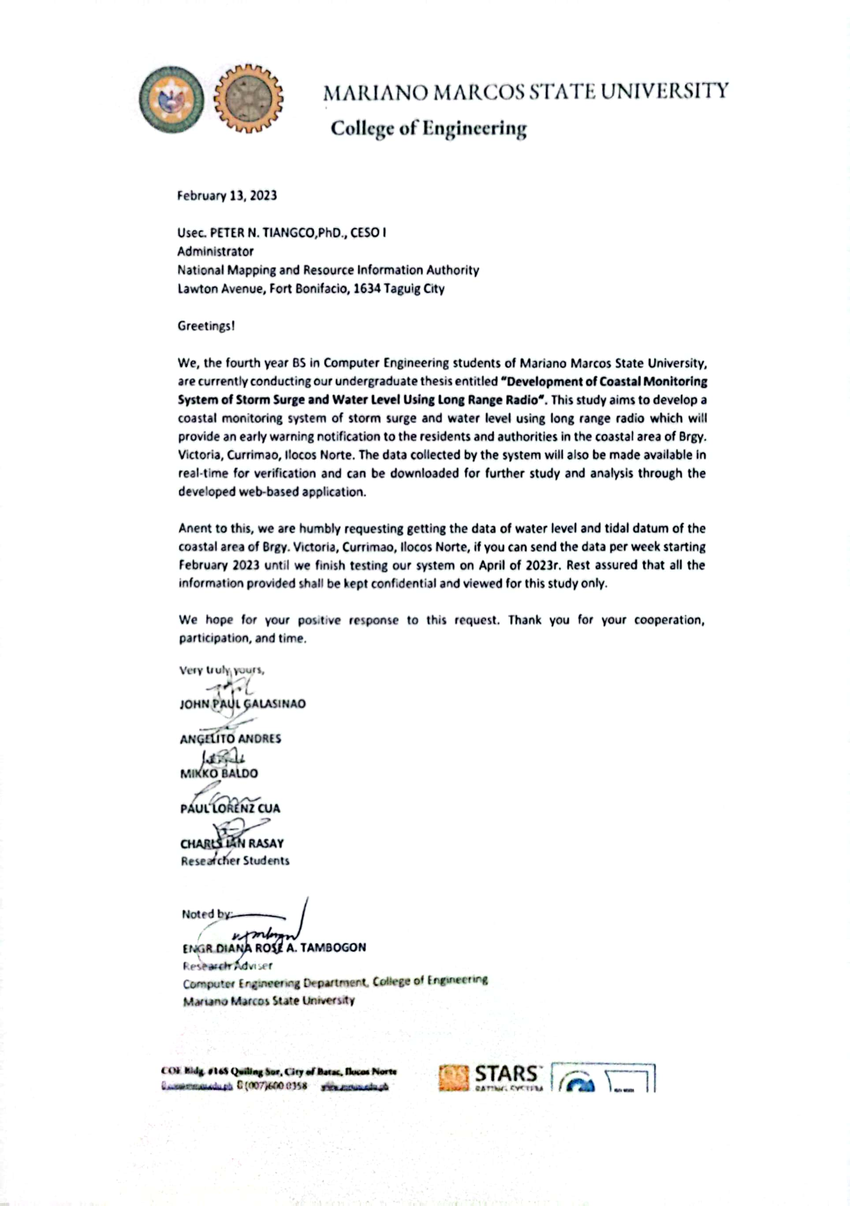

**Appendix B. Conformity of Revisions**

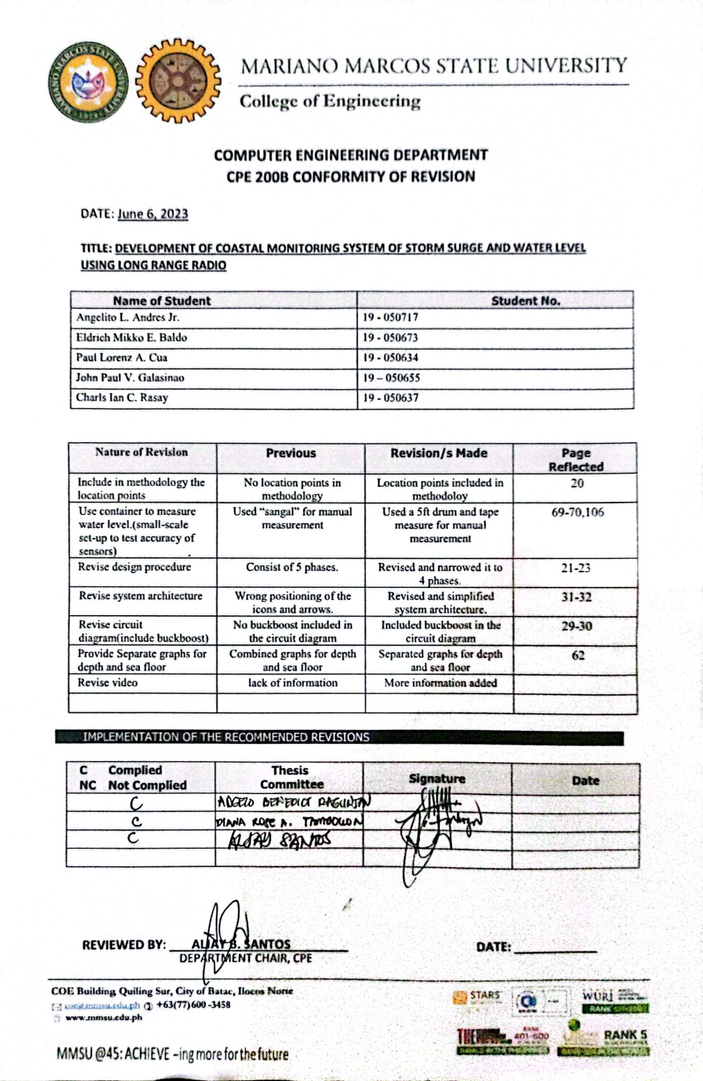

**Appendix C. Nomination Form for Undergraduate Thesis**

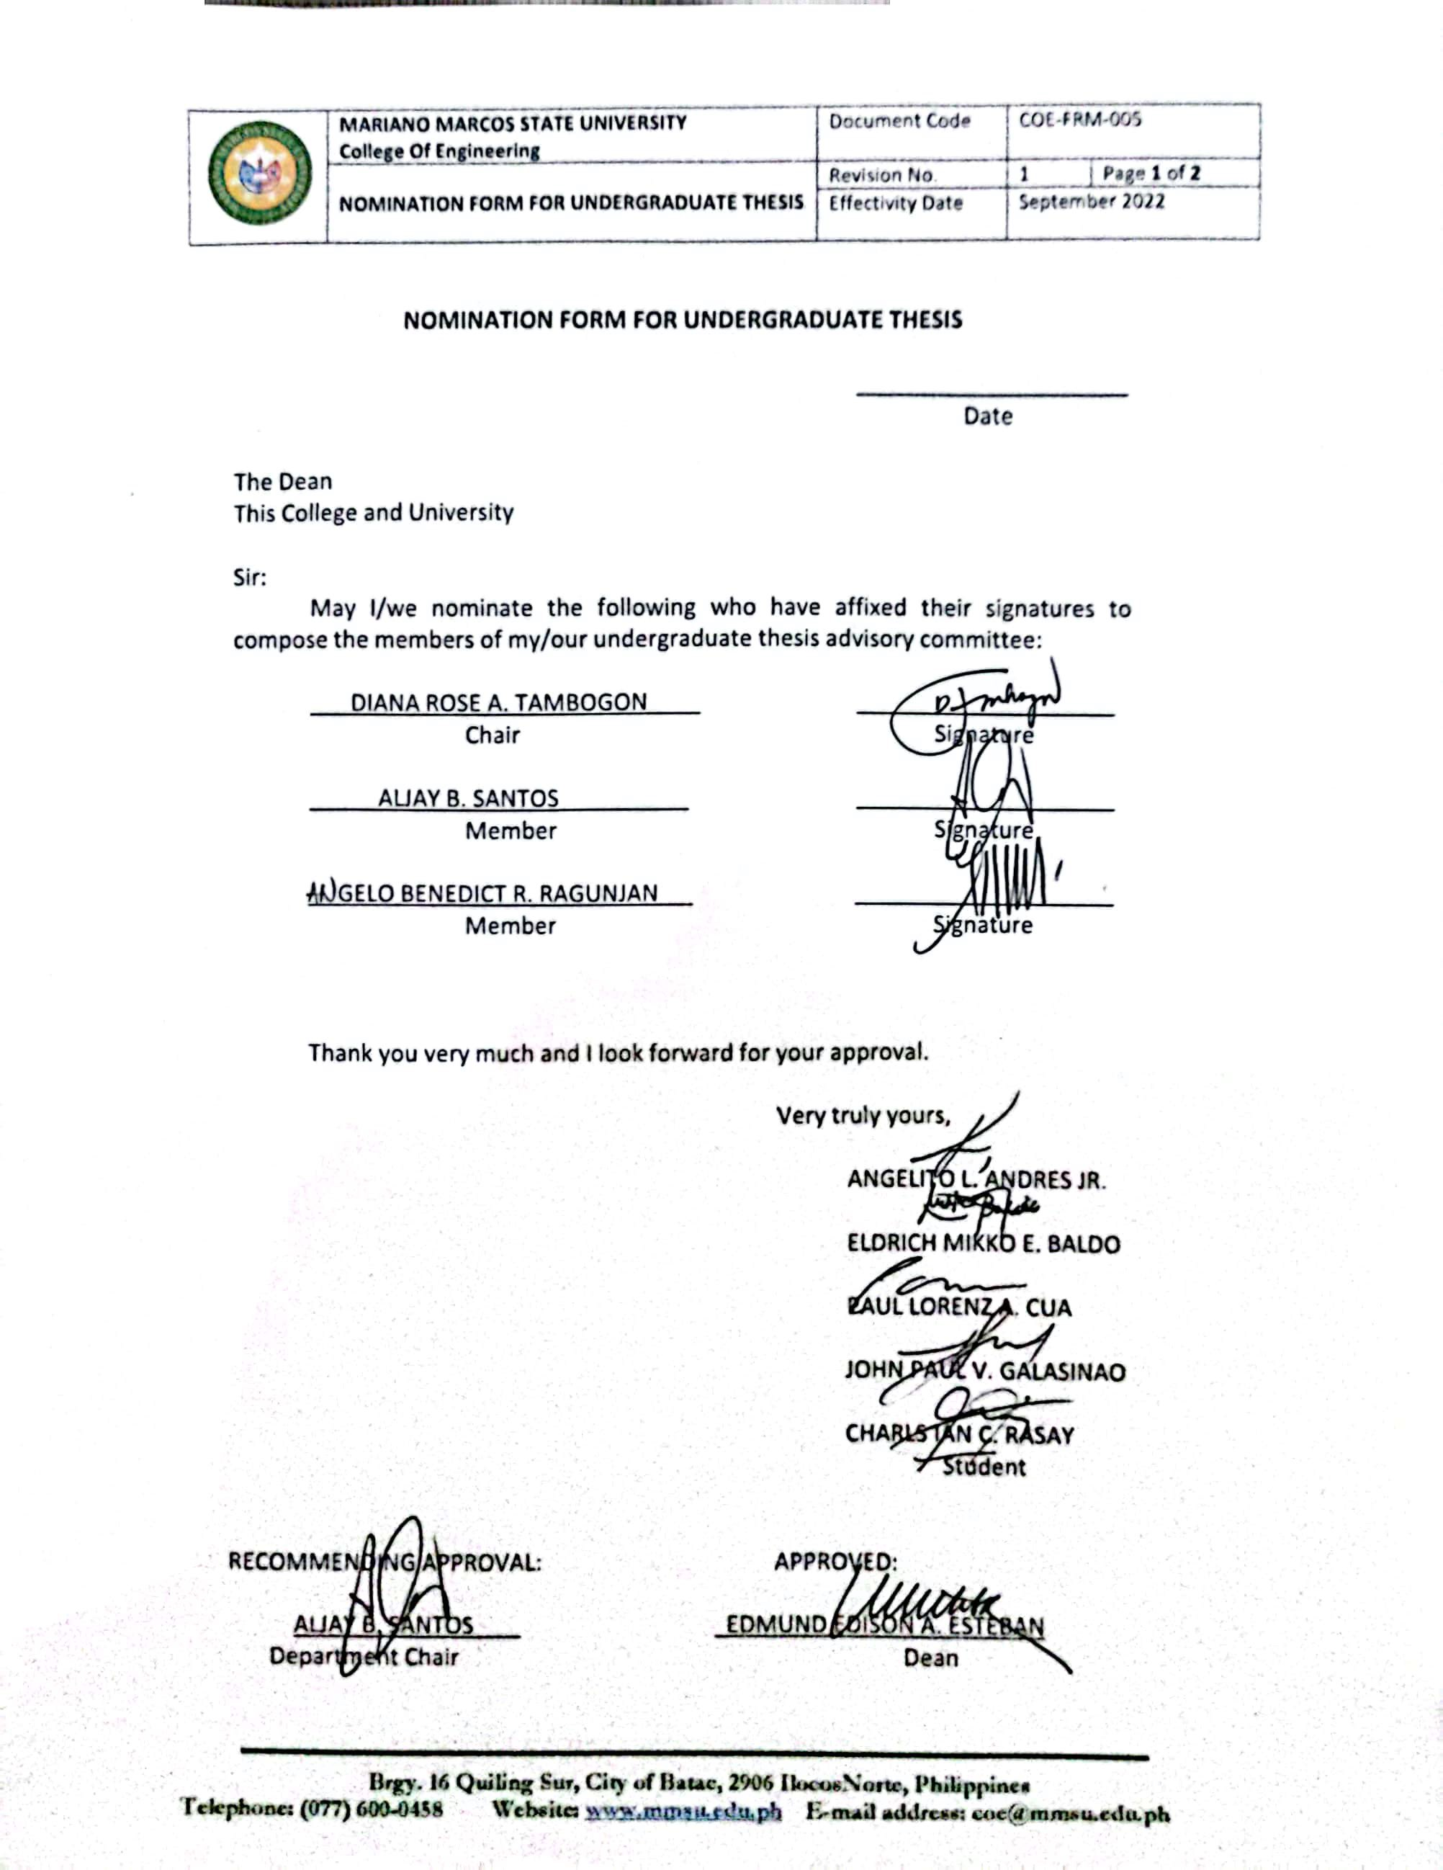

**Appendix D. Actions/Recommendations of the Thesis Advisory Committee**

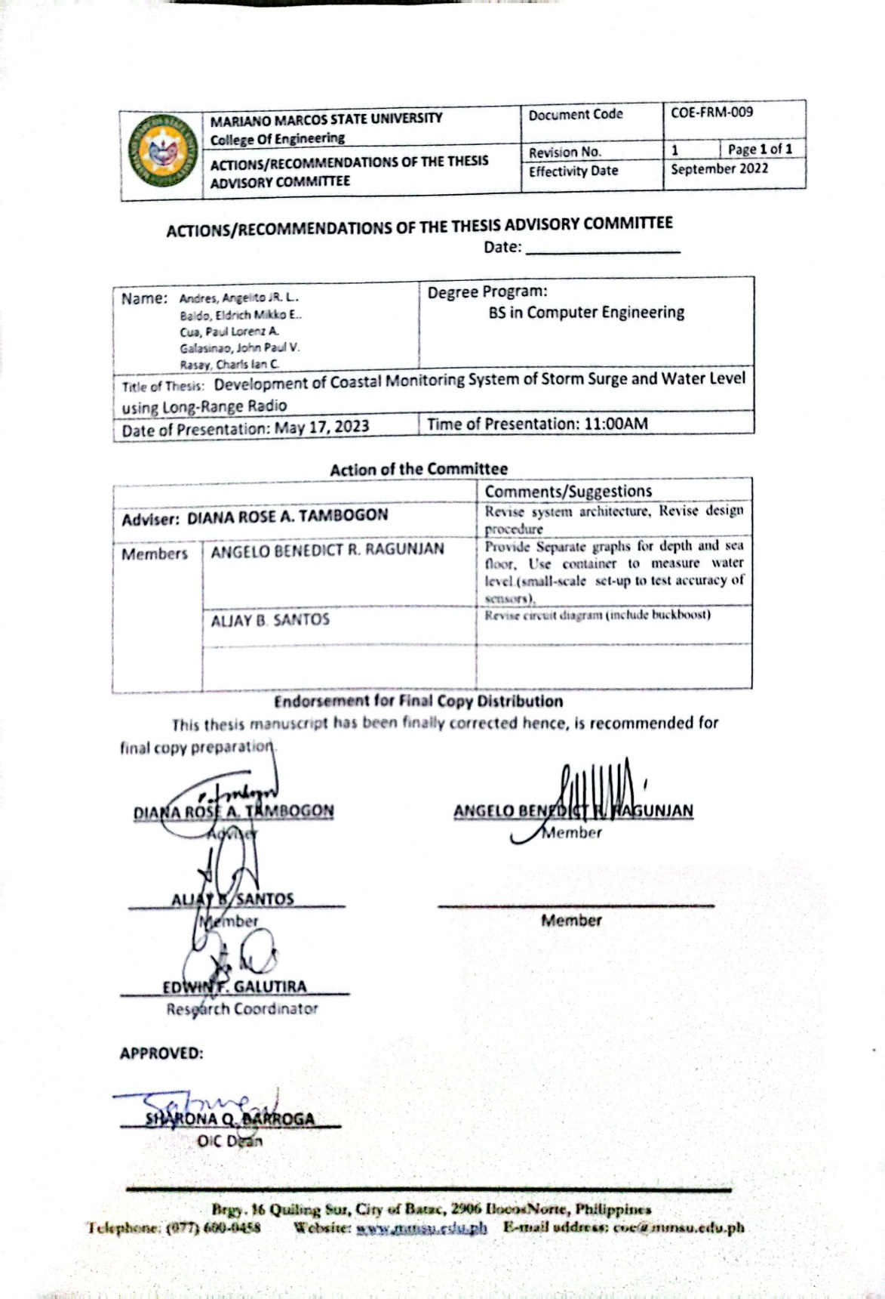

**Appendix E. Application for Undergraduate Thesis Manuscript Presentation**



**Appendix F. Cover Letter**

**Appendix G. Functionality Testing Sheets**

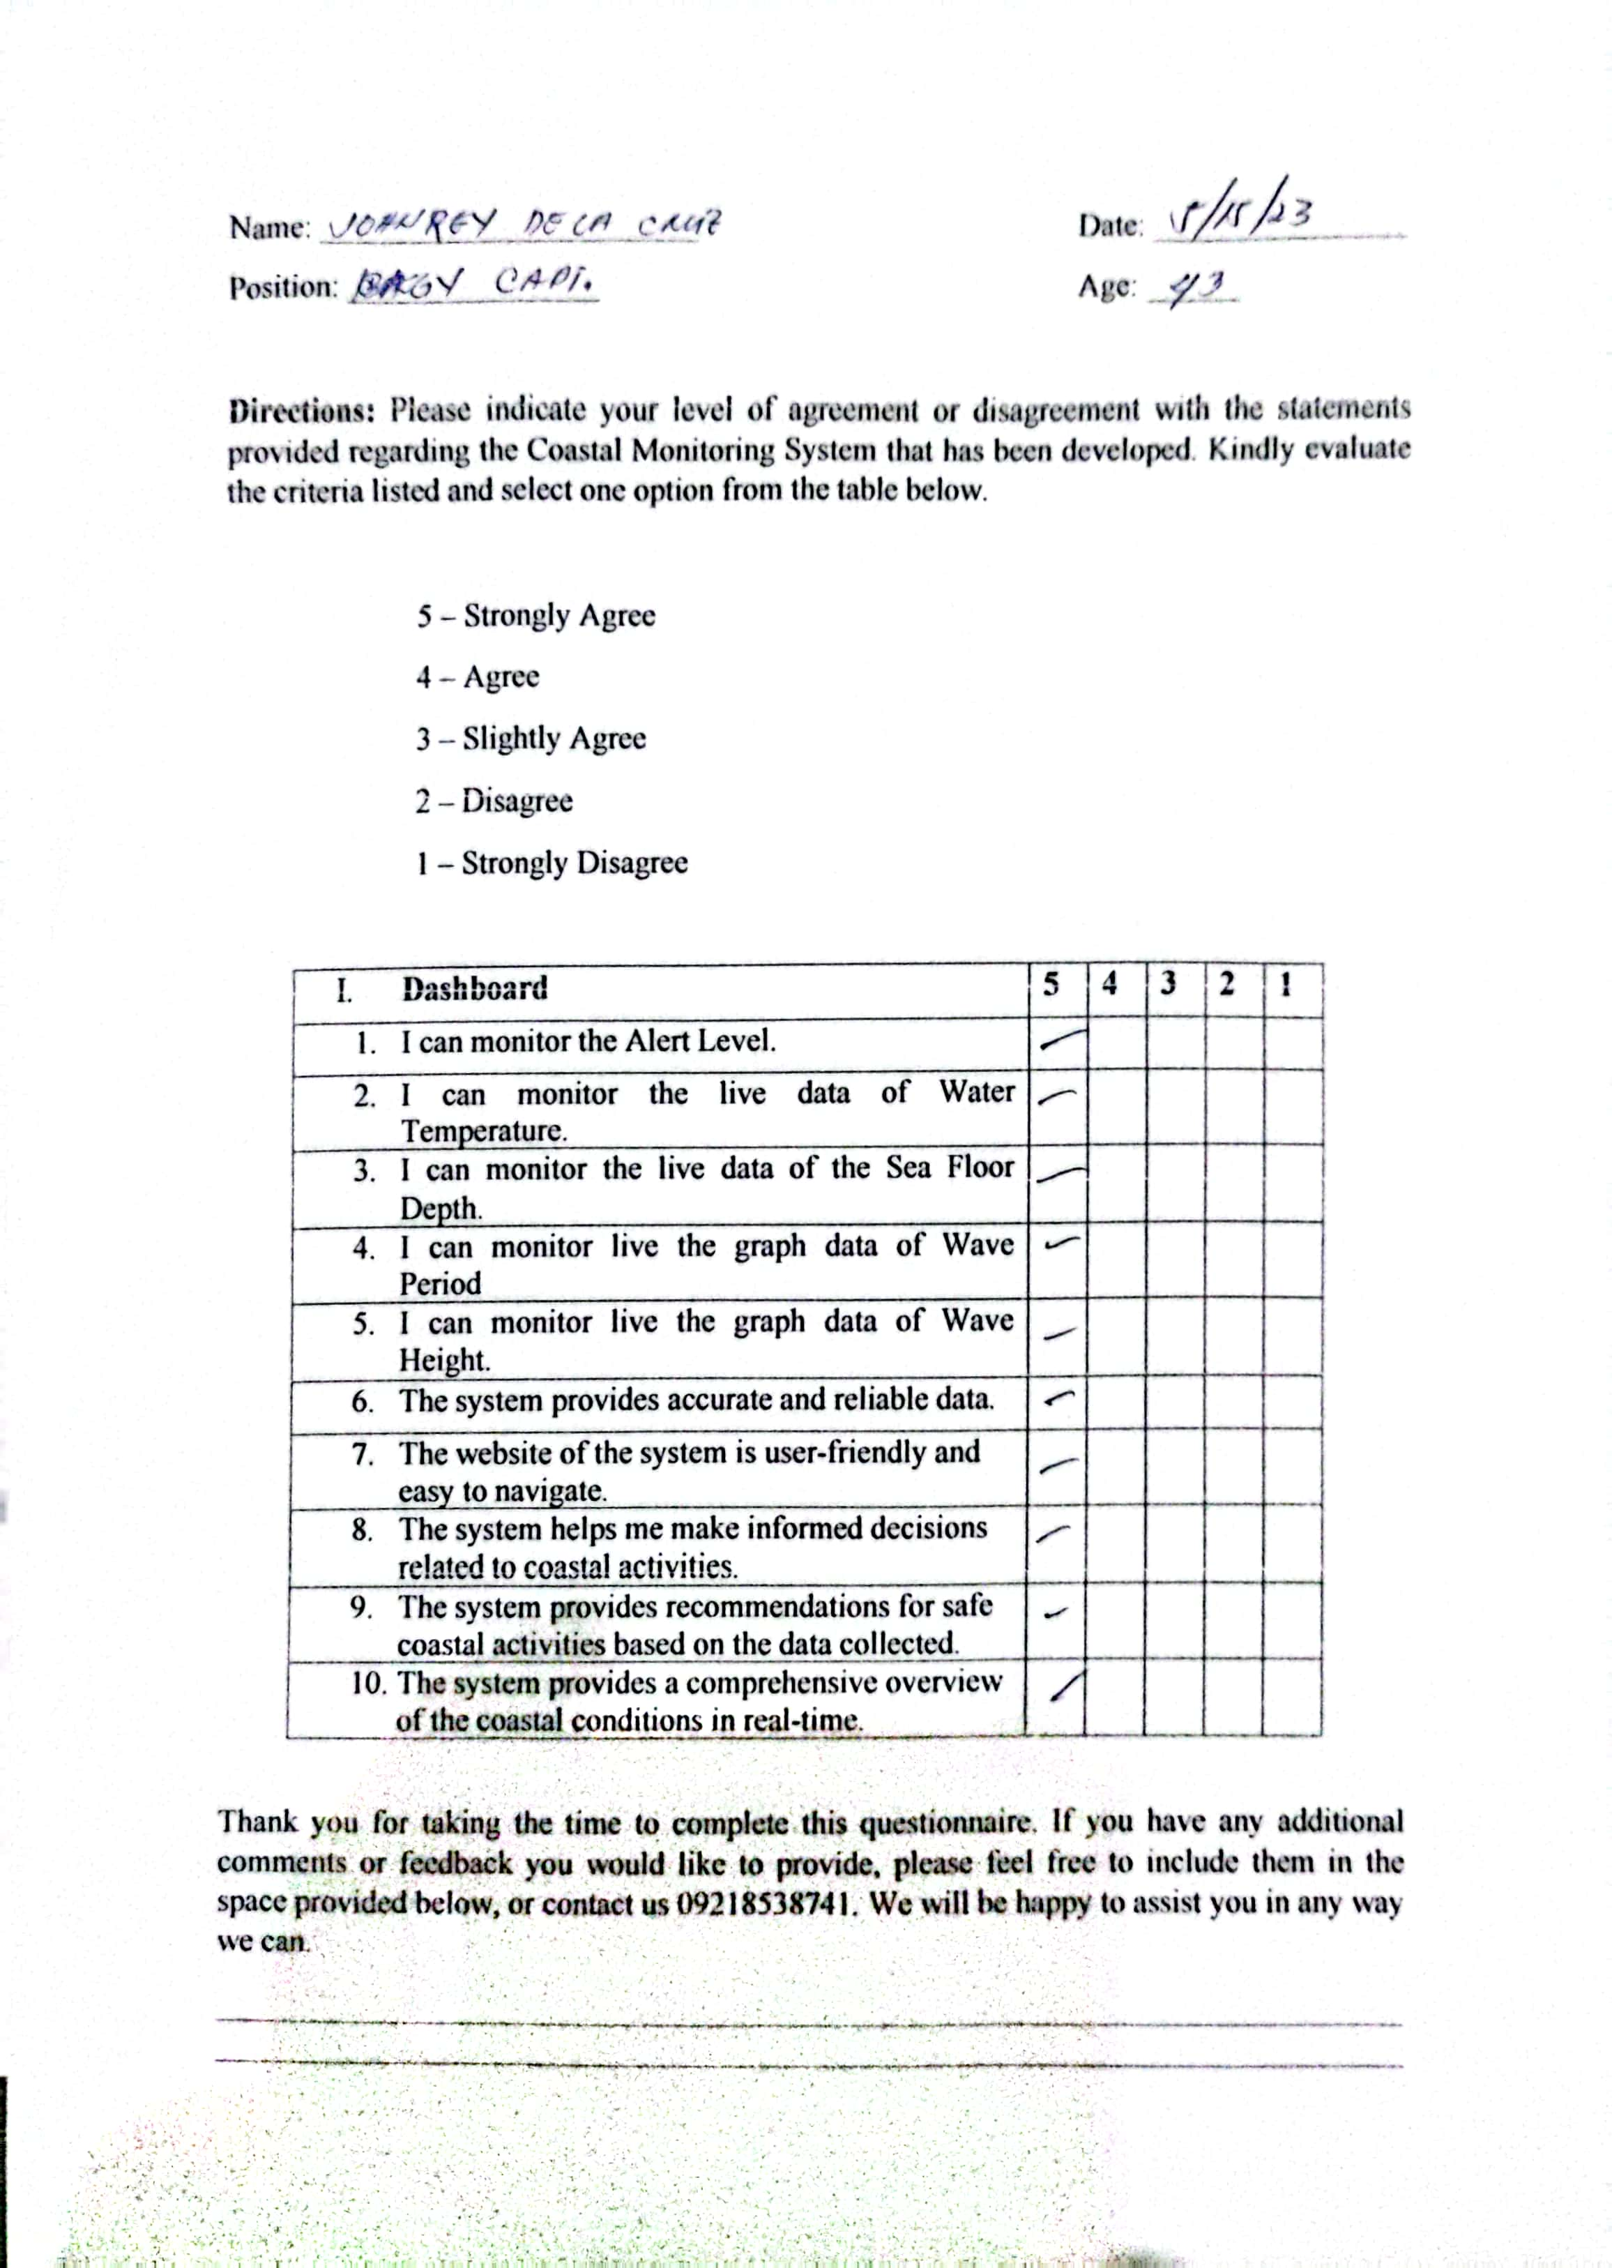

**Appendix H. Questionnaire**

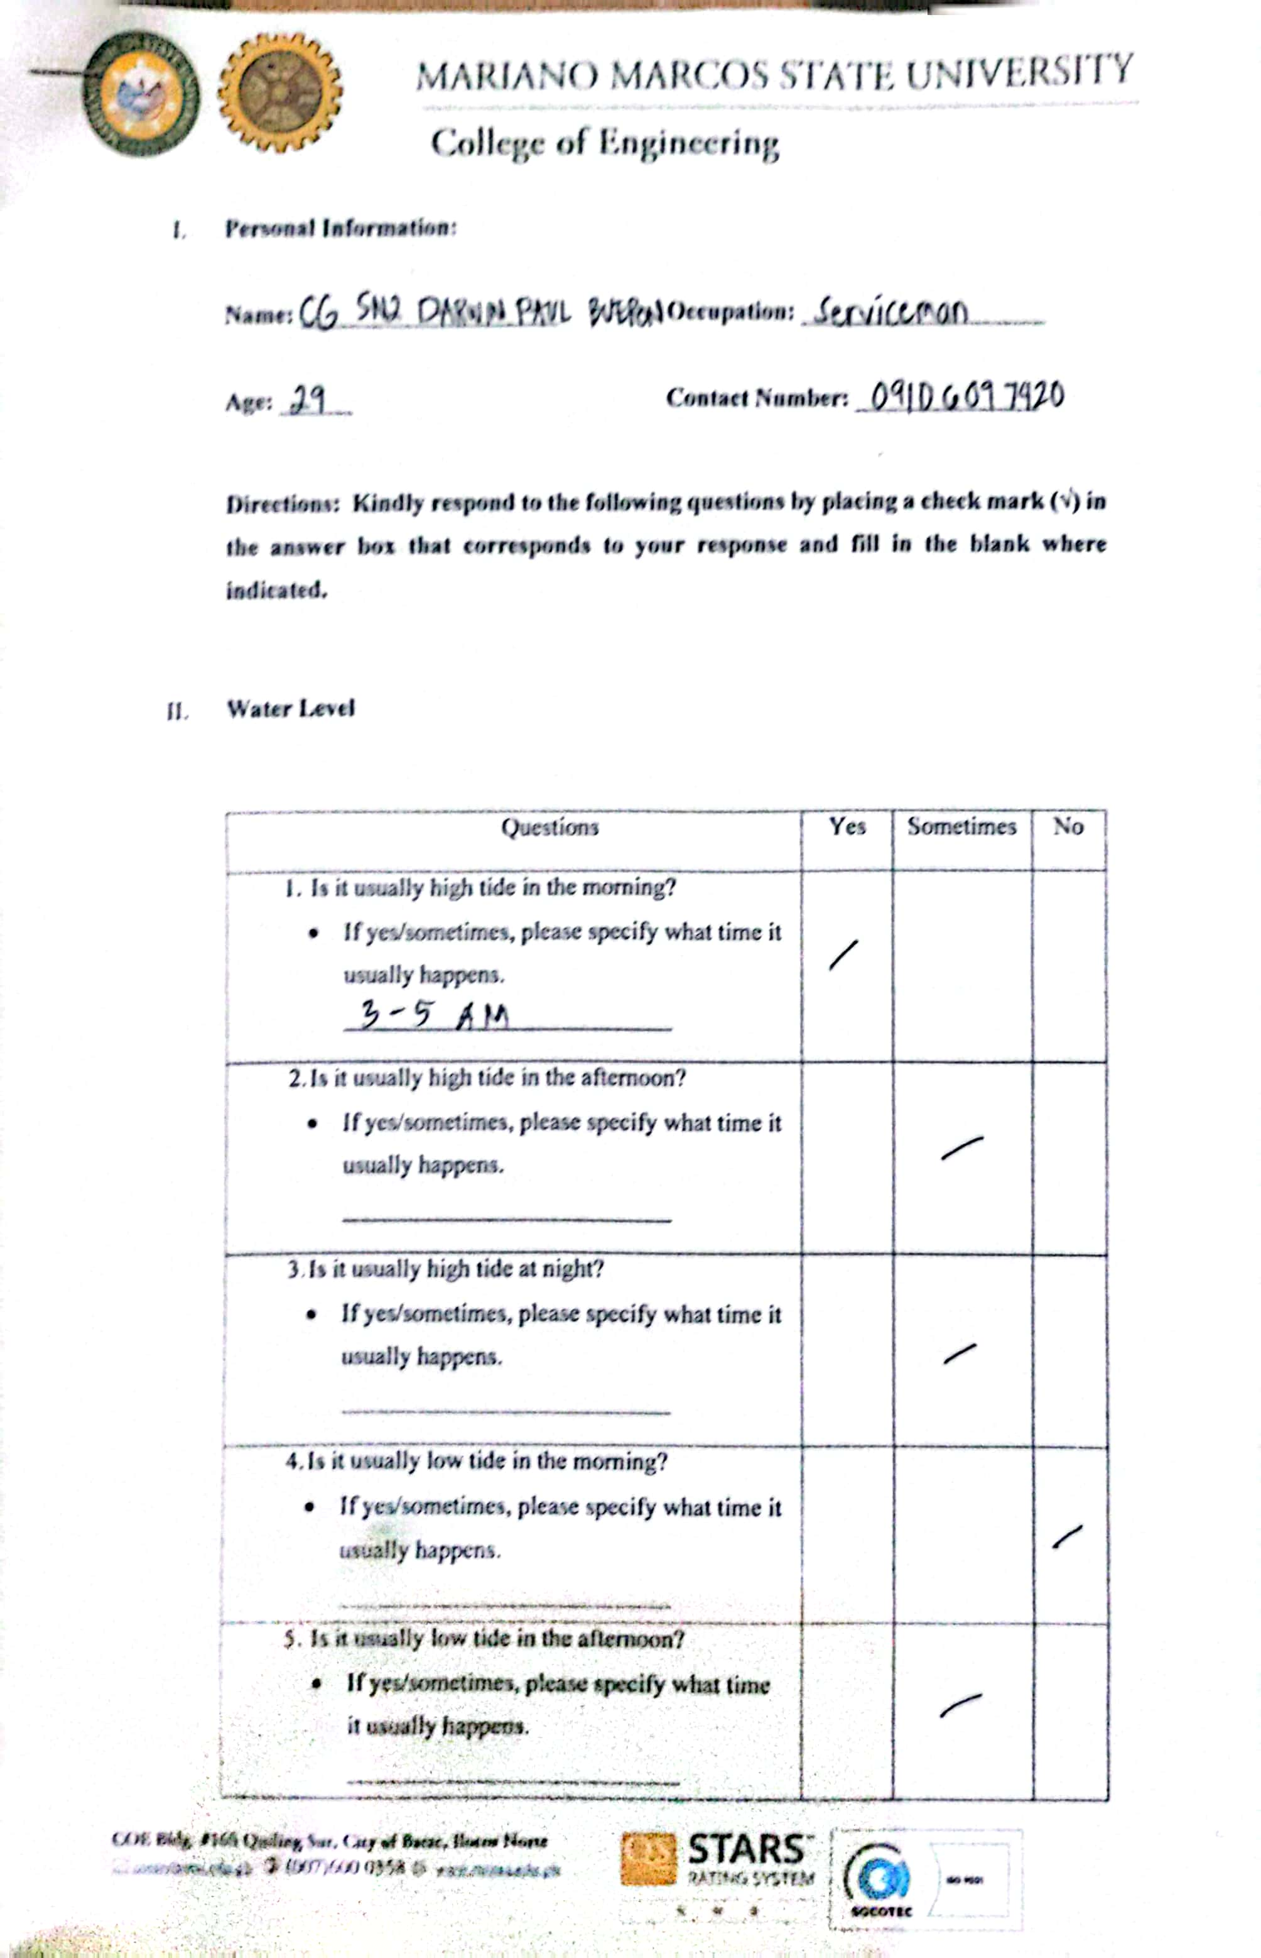

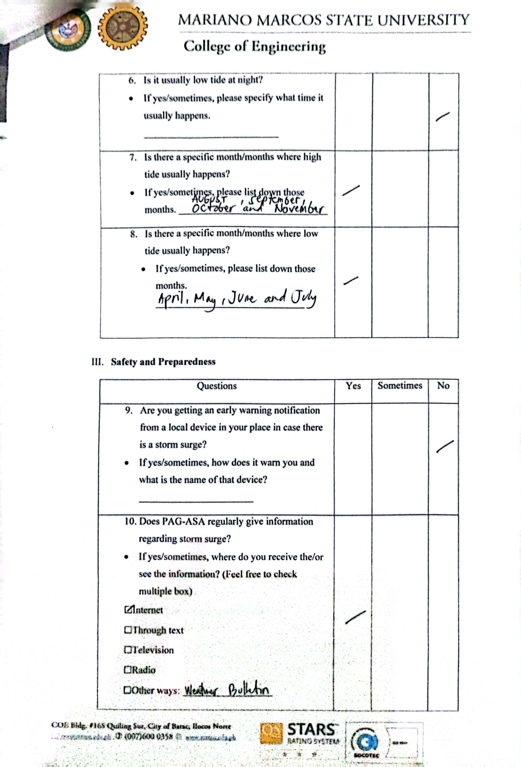

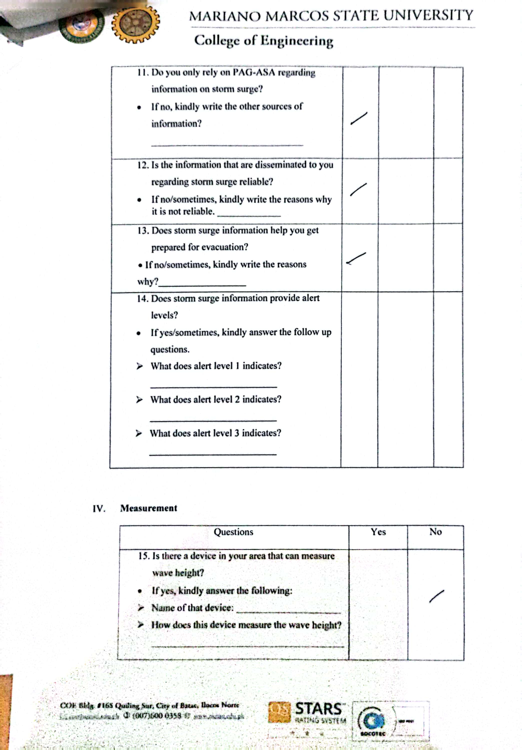

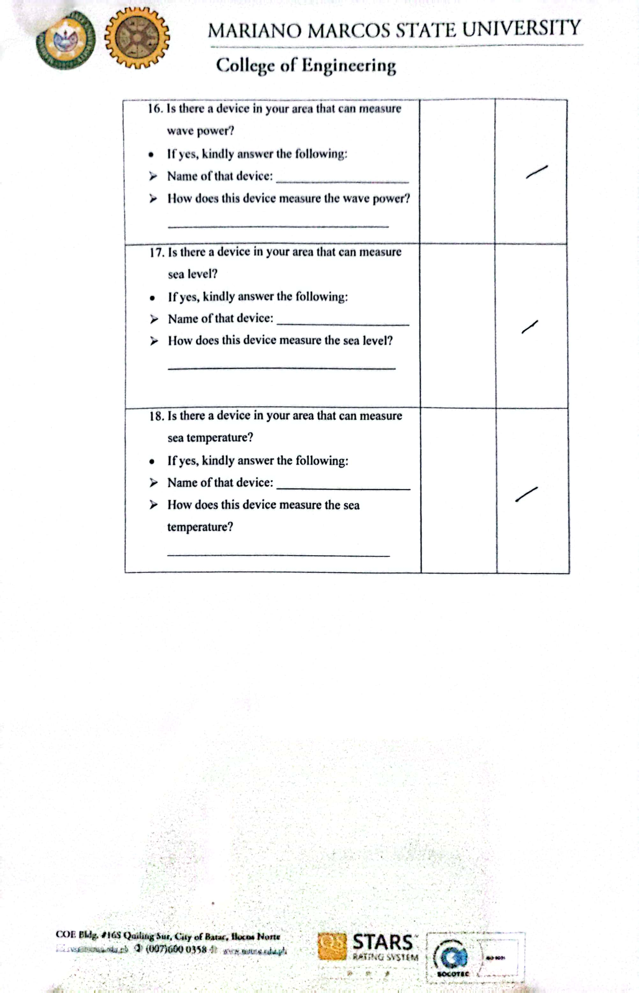

**Appendix I. Documentation Photos**

**Circuit Assembly**

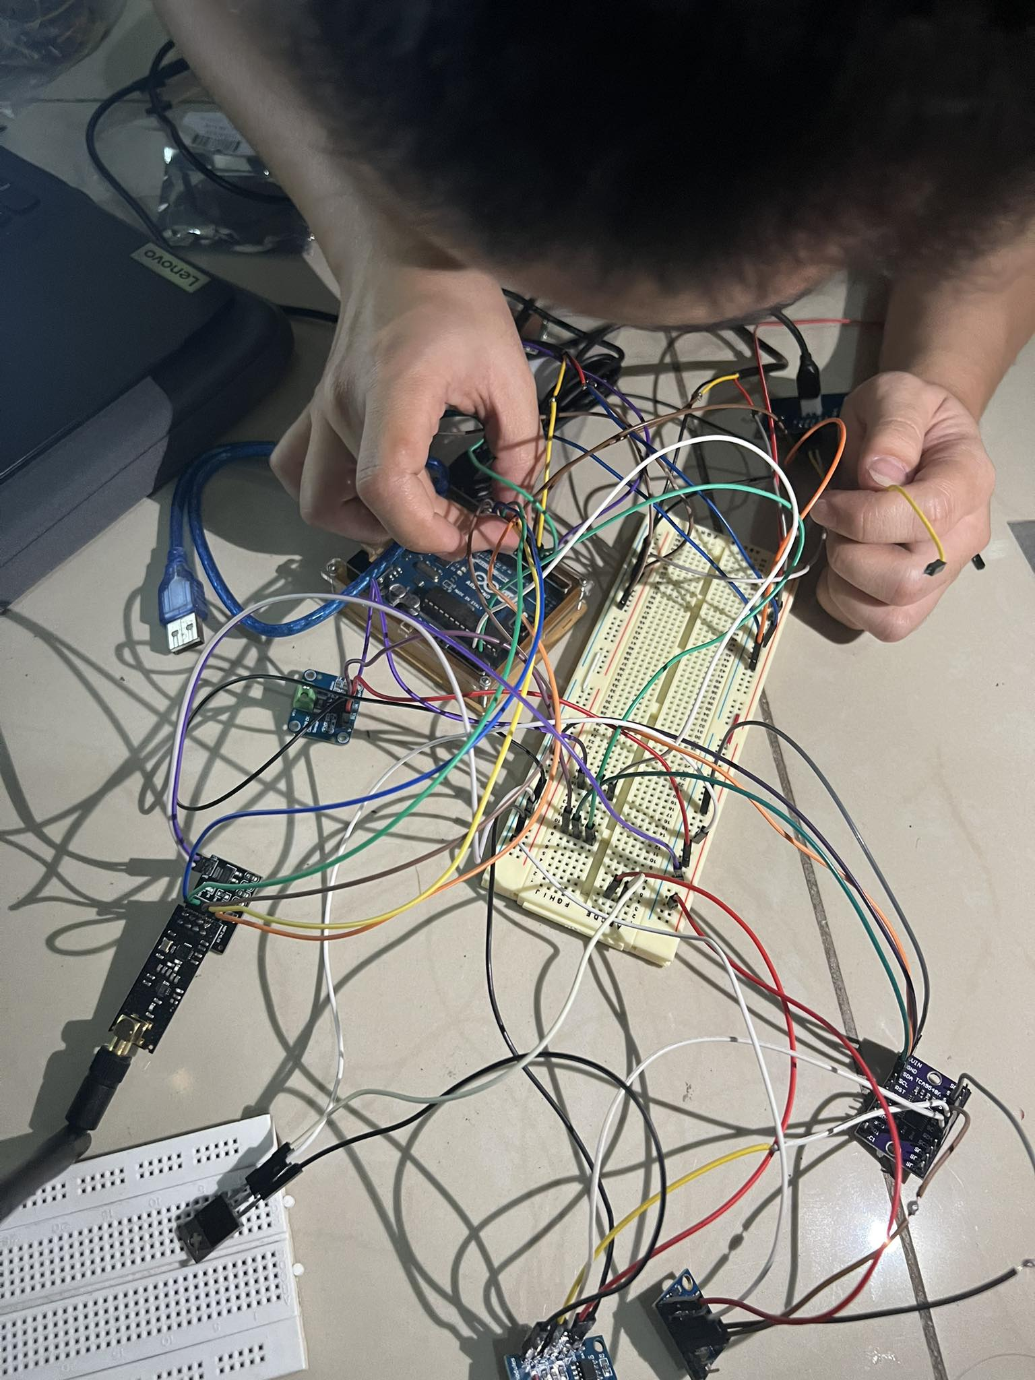

Figure 45. Circuit Assembly.

The figure shows the researcher assembling the circuit.

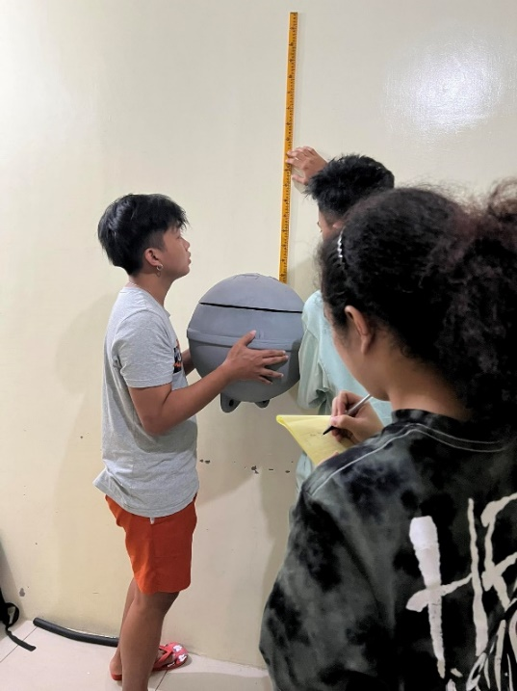**Web Development and Manual Testing**

Figure 46. Manual Testing.

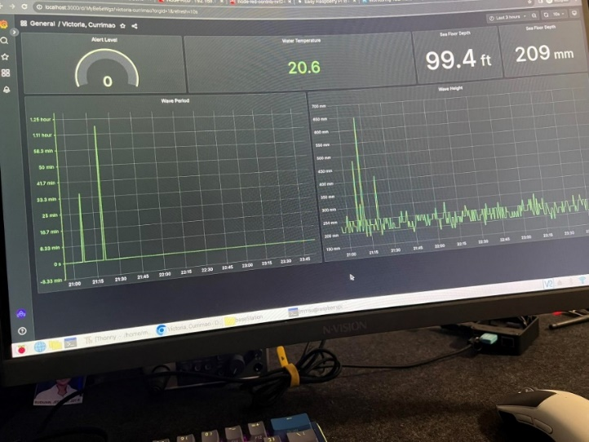 The figure shows the researchers initial testing of the overall circuit placed inside the buoy.

Figure 47. Prototype Dashboard.

The figure also shows the prototype design of the dashboard.

**Buoy Sealing**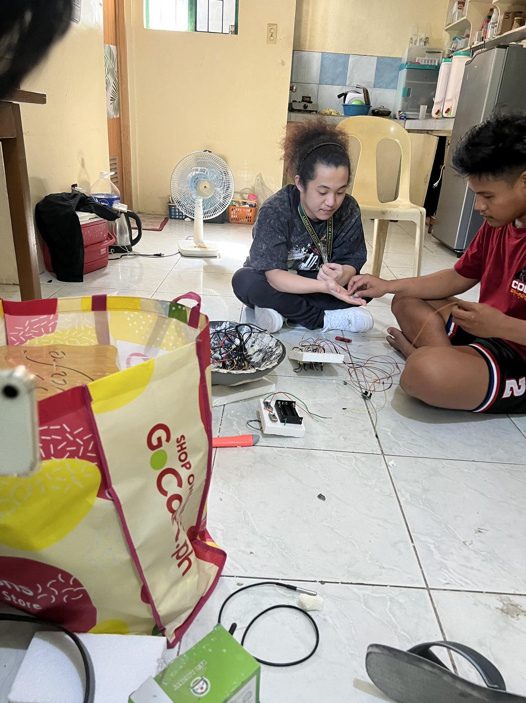

Figure 48. Buoy Sealing.

The figure shows the researchers creating a mount of the circuit inside the buoy.

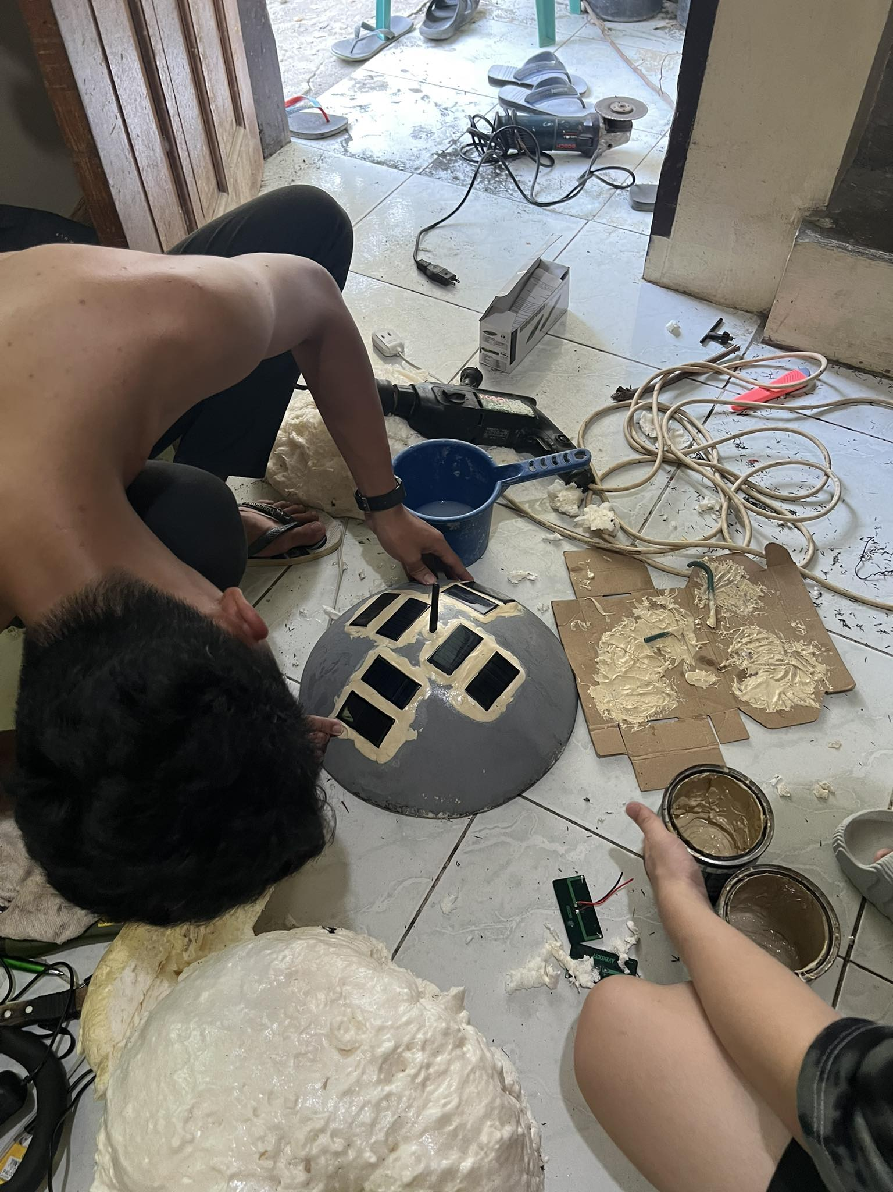

Figure 49. Sealing the Head of Buoy.

The figure shows the researcher mounting and sealing the solar panels on the buoy.

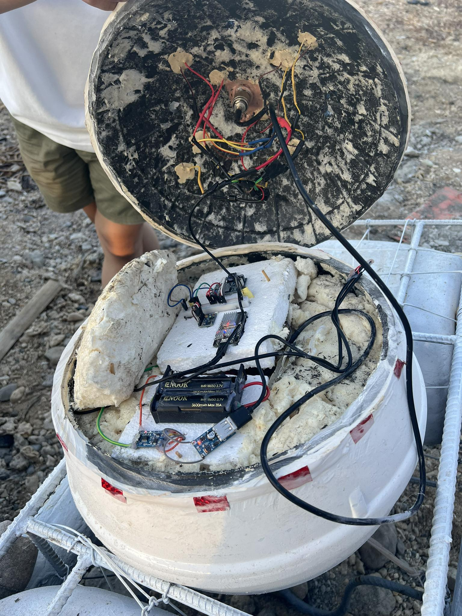

Figure 50. Inside the Buoy.

The figure shows the inside of the buoy.

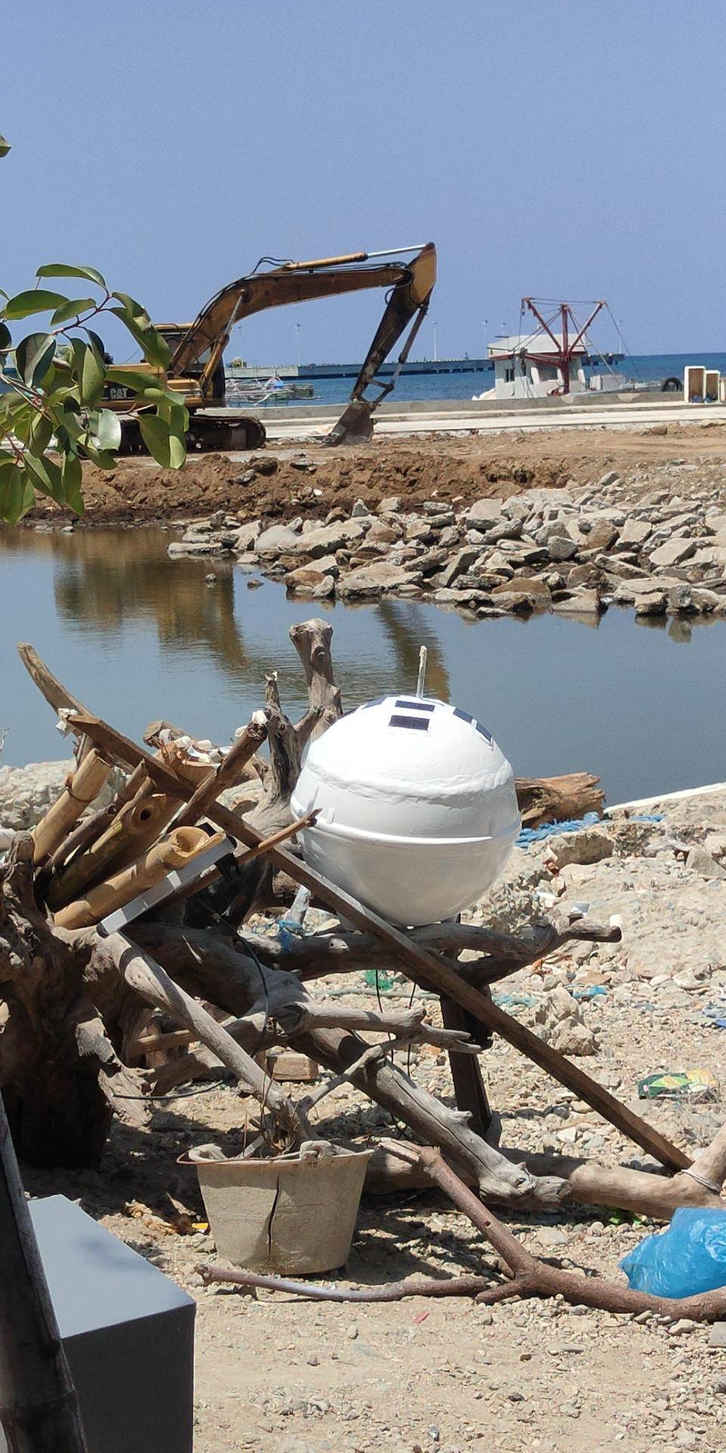

Figure 51. Buoy before deployment.

The figure shows the buoy before deployment.

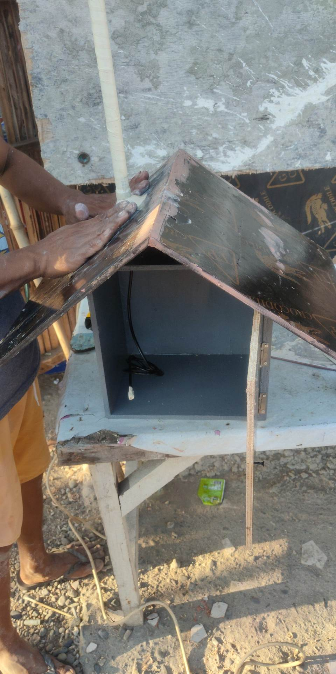

Figure 52. Sealing and water proofing of the base.

The figure shows the sealing and water proofing of the base station.

**Testing and Deployment**

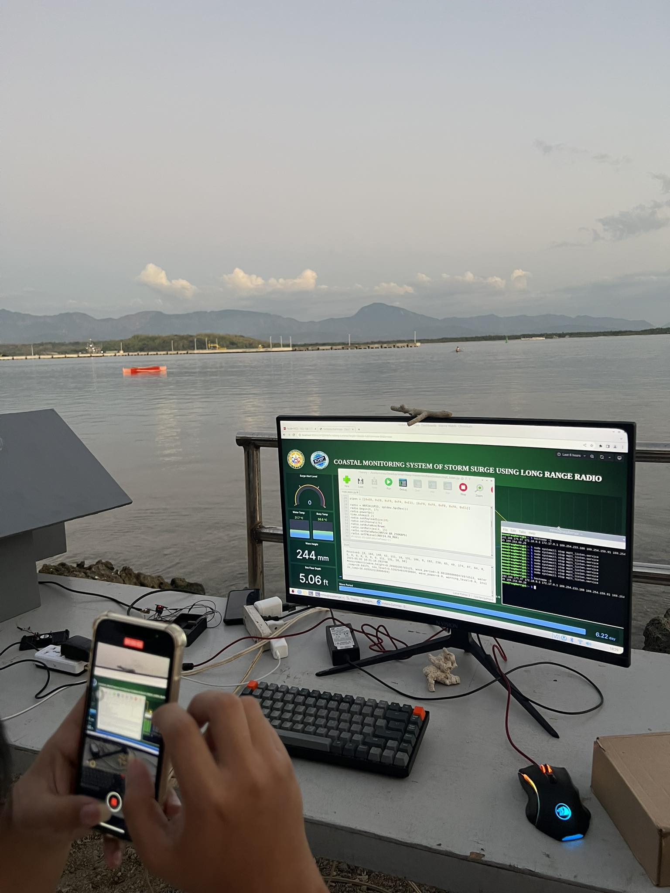

Figure 53. Deployment with dashboard.

The figure shows the researchers deployment of the system at Cabugao, Ilocos Sur

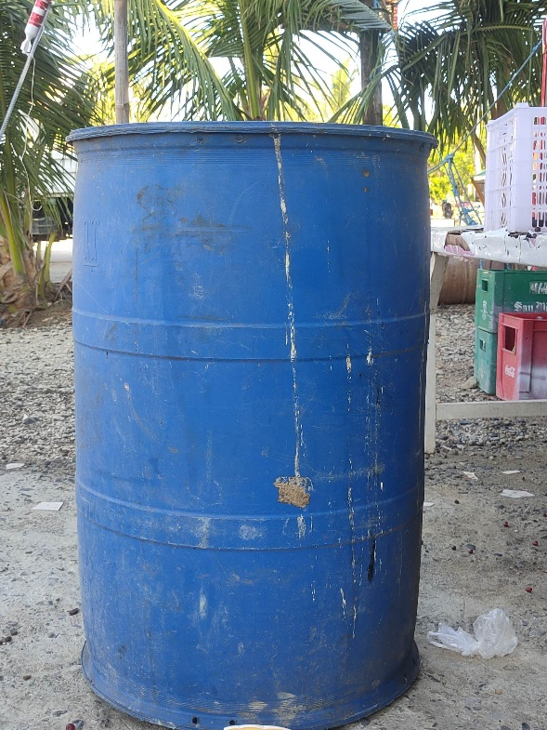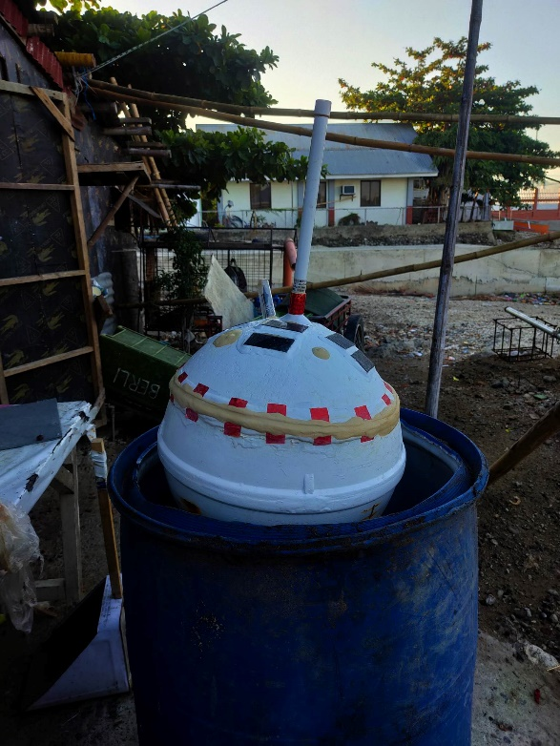

Figure 54. Drum used for testing. Figure 54.1 Drum with Buoy.

The figures shows the testing of the buoy’s sonic sensor using a drum and tape measure.